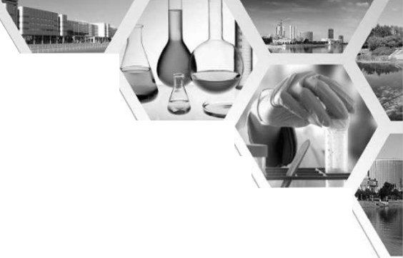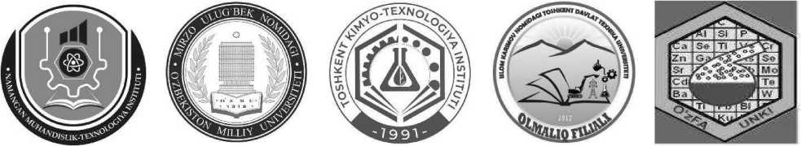

O‘ZBEKISTON RESPUBLIKASI

OLIY TA’LIM, FAN VA INNOVATSIYALAR VAZIRLIGI

NAMANGAN MUHANDISLIK-TEXNOLOGIYAINSTITUTI

O‘ZBEKISTON MILLIY UNIVERSITETIKIMYO FAKULTETI

TOSHKENT KIMYO-TEXNOLOGIYAINSTITUTI

TOSHKENT DAVLAT TEXNIKA UNIVERSITETI OLMALIQ FILIALI

O‘ZRFA UMUMIY VA NOORGANIK KIMYO INSTITUTI

KIMYO FANINING MUAMMOLARI, SANOAT

SOHALARIGA TATBIQIVA YASHIL

TEXNOLOGIYALAR MAVZUSIDAGIXALQARO

ANJUMAN

(18-19 aprel 2025 yil)

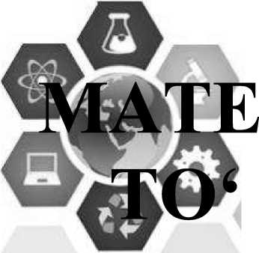

RIALLAR  
PLAMI

ISBN: 978-9910-695-76-6

NAMANGAN

**KIMYO FANLARINI O‘QITISHNING NAZARIYASI VA  
 METODLARI**“Kimyo fanining muammolari, sanoat sohalariga **L**tatbiqi vayashil texnologiyalar mavzusidagi xalqaro anjumani //

-Наг bir o‘quvchi faol ishtirok etadi, passiv o‘quvchilar ham rag‘batlantiriladi.

-Yodlash emas, balki tushunishga asoslangan o‘rgatish usuli qo‘llaniladi.

-Zaryad muvozanatini tushunishga yordam beradi.

-Interaktiv yondashuv asosida tanqidiy fikrlash va izohlash ko‘nikmasi shakllanadi.

-Har xil darajadagi o‘quvchilar uchun moslashtirish imkoniyati mavjud.

-Birgalikda ishlash va jamoaviy o'rganish muhiti yaratadi.

**Kamchiliklari va tanqidiy yondashuv** Har qanday metodda bo‘lgani kabi, zar toshlari  
metodikasida ham ayrim kamchiliklar mavjud:

-Nazariy asos yetarlicha mustahkam bo‘lmasa, faqat taxmin bilan o‘yin o‘ynalishi mumkin.

-Formulani tuzish sababini chuqur izohlash ba’zida amalga oshmaydi.

-Murakkab ionlar, kompleks birikmalar bilan ishlash qiyin kechishi mumkin.

-O‘yin jarayonida vaqtni to‘g‘ri taqsimlamaslikka olib kelishi mumkin.

-Har doim barcha o'quvchilami birdek jalb qilish qiyin.

Shunday bo‘lsa-da, bu kamchiliklar metodikani to‘g‘ri tashkil qilish, o‘qituvchi tomonidan  
puxta tayyorlanish orqali bartaraf etilishi mumkin.

**Taklif va yechimlar**

Har bir o‘yindan keyin muhokama qilishni yo‘lga qo‘yish: nima uchun aynan shunday formula  
hosil bo‘ldi?

Zarlami o‘quvchilaming bilim darajasiga moslab tayyorlash: boshlang‘ichlar uchun oddiy  
ionlar, ilg'orlar uchun komplekslar.

O‘yin asosida mini-loyihalar tayyorlash: “Tushgan formula qayerda qo‘llaniladi?”, “Bu modda  
qanday xossalarga ega?”

O‘yin natijalarini baholashda analitik tafakkur va izohlash qobiliyatiga e’tibor qaratish

Didaktik zarlami kompyuter grafikasi asosida raqamlashtirish va onlayn shaklga o‘tkazish

Zar toshlari metodikasi - bu kimyo fanini interaktiv, tushunarli, ijodiy va samarali o'qitish  
imkonini bemvchi zamonaviy yondashuvdir. U o‘quvchilarda nafaqat formulani eslab qolish, balki  
uni mantiqiy asosda tuzish, izohlash, hayotdagi qo‘llanilishini tushunish kabi chuqur bilimlami  
shakllantiradi. Ta’limda innovatsion usullardan foydalanish nafaqat o‘qituvchining, balki  
o‘quvchining ham bilim olishga bo‘lgan yondashuvini o‘zgartiradi. Ushbu metodika orqali  
o‘quvchilar mustaqil, tanqidiy va tizimli fikrlovchi shaxs sifatida shakllanadi.

***FOYDALANILGAN ADABIYOTLAR***

1. M.Nishonov, Sh.Mamajonov, V.Xo’jayev "Kimyo o’qitish metodikasi".T.O’qituvchi. 2002 y.
2. Interaktiv metodlar to‘plami - O‘zbekiston Respublikasi Xalq ta’limi vazirligi  
   <https://www.education.com/activity/chemistry-dice/>
3. Raxmatullayev N.G., Omonov X.T., Mirkomilov Sh.M. Kimyo o‘qitish metodikasi. Toshkent.  
   Nizomiy nomidagi TDPU, 2008.

**THE IMPORTANCE OF CHEMICALSIN THE HUMAN BODY  
(INTEGRATED CHEMISTRY,BIOLOGY AND ENGLISH)  
Ochilova Madina Gulom qizi., Shoimova Aziza A’zam qizi., Xasanova Nargiza Ismagilovna**

Student of the 2nd year, Chemistry Department, Faculty of Physics and Chemistry, ChDPU.

[Ochilovamadina73@gmail.com](mailto:Ochilovamadina73@gmail.com)

AbstractChemical substances play a fundamental role in sustaining human life, far beyond  
basic nutrition. Essential elements such as calcium, potassium, and magnesium are involved in  
structural integrity, nerve signaling, and enzyme activation, forming the biochemical foundation of  
bodily fimctions. Trace elements like zinc, iron, and selenium, though required in minute amounts,  
are vital for immune defense, oxygen transport, and cellular protection. Hormonal activity, metabolic  
rate, and pH balance are tightly regulated by specific chemical compounds and ions. Moreover,  
imbalances in these substances often serve as early indicators of diseases, making their presence and  
1882

**KIMYO FANLARINI O‘QITISHNING NAZARIYASI VA  
 METODLARI**“Kimyo fanining muammolari, sanoat sohalariga **L**tatbiqi vayashil texnologiyalar mavzusidagi xalqaro anjumani //

proportion critical to both health maintenance and medical diagnostics. Understanding the role of  
these chemicals reveals how intricately chemistry govems the human body, and highlights the  
necessity of maintaining intemal chemical harmony for optimal health.

**Keywords.** chemical substances, human body, biochemical processes, trace elements,  
enzymes, metabolism, hormonal balance, electrolyte balance, cellular functions, health diagnostics,  
disease prevention, biological functions, experimental leaming, scientific competence,  
interdisciplinary teaching, student engagement, innovative pedagogy, educational quality.

**Introduction.The** human body is an intricate system of chemical interactions, where various  
substances play critical roles in maintaining life and overall health. Chemical elements such as  
calcium, phosphoms, and magnesium form the stmctural components of bones and teeth, while trace  
elements like zinc, iron, and selenium contribute to immune functions and cell protection.  
Additionally, enzymes and hormones, driven by specific chemical substances, regulate vital processes  
such as metabolism, energy production, and growth. The balance of electrolytes like sodium,  
potassium, and chloride is equally essential for maintaining proper nerve function, muscle  
contraction, and fluid balance. Dismptions in these chemical processes often indicate underlying  
health issues and are key markers in the diagnosis of diseases. This paper explores the essential  
chemical substances in the human body and their indispensable roles in maintaining health,  
supporting growth, and preventing disease. Understanding the chemistry behind the body’s functions  
is crucial for advancing health science and improving medical practices.

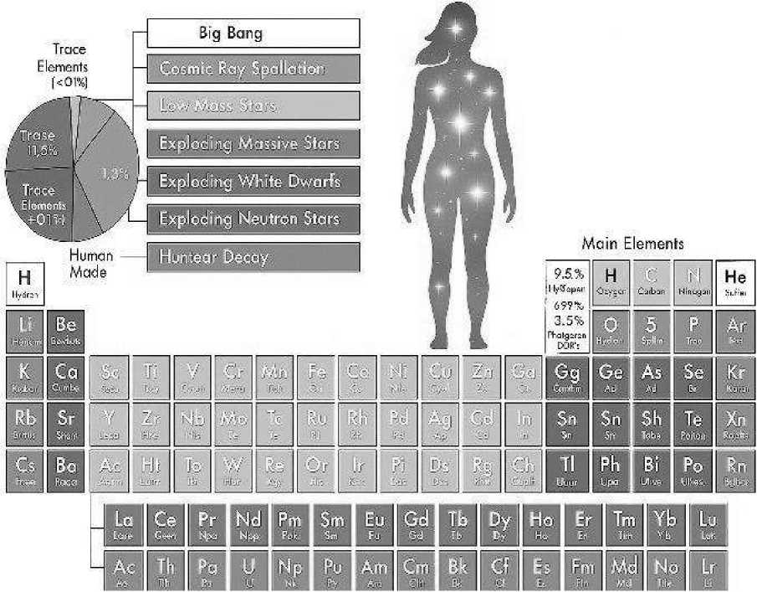

The human body relies on a vast array of chemical substances that work together to sustain life.  
These substances are essential not only for the stmctural integrity of the body but also for its  
continuous metabolic and biochemical functions.

**KIMYO FANLARINI O‘QITISHNING NAZARIYASI VA  
 METODLARI**“Kimyo fanining muammolari, sanoat sohalariga **L**tatbiqi vayashil texnologiyalar mavzusidagi xalqaro anjumani //

1. Chemical Elements and Structural Integrity.The body’s structure is heavily dependent on  
   chemical elements like calcium, phosphorus, and magnesium. Calcium is a critical component of  
   bones and teeth, providing them with strength and durability. Phosphorus, along with calcium, helps  
   form the mineral structure of bones, while magnesium supports the function of muscles and nerves.  
   These elements contribute to maintaining the body's skeletal framework, which is essential for  
   mobility and physical health.
2. Trace Elements and Enzyme Functions.Trace elements, although required in minute  
   quantities, play crucial roles in various biochemical processes. Zinc, for instance, is vital for immune  
   fiinction, wound healing, and the synthesis of proteins and DNA. fron is a key component of  
   hemoglobin, enabling oxygen transport throughout the body. Selenium, a powerful antioxidant, helps  
   protect cells from oxidative stress, reducing the risk of chronic diseases such as cancer and heart  
   disease.
3. Metabolism and Energy Production.Chemical substances are at the heart of metabolism, the  
   process by which the body converts food into energy. Enzymes, which are proteins that speed up  
   chemical reactions, rely on minerals like magnesium and iron to function. These enzymes facilitate  
   the breakdown of food molecules, allowing the body to absorb nutrients and produce energy. Without  
   these essential chemicals, vital metabolic processes would cease, leading to a collapse of bodily  
   functions.
4. Hormonal Regulation and Chemical Signaling.Hormones are another key group of chemical  
   substances that regulate numerous bodily functions. For instance, thyroid hormones, produced with  
   the help of iodine, regulate metabolism and energy production. Insulin, produced by the pancreas,  
   controls blood sugar levels, while adrenaline, released during stress, helps prepare the body for “fight  
   or flight” responses. These chemical signals are integral to maintaining homeostasis, the stable  
   intemal conditions necessary for health.
5. Electrolytes and Fluid Balance.Electrolytes, such as sodium, potassium, and chloride, are  
   essential for maintaining fluid balance and ensuring proper function of cells. These charged particles  
   help regulate the body’s pH levels, nerve impulses, and muscle contractions. An imbalance in  
   electrolytes can lead to severe health issues, including dehydration, muscle weakness, or even cardiac  
   arrest.
6. Health Indicators and Disease PreventionChemical imbalances in the body often serve as  
   early indicators of health issues. For example, elevated blood glucose levels may point to diabetes,  
   while abnormal cholesterol levels can indicate a risk for heart disease. By understanding the roles of  
   various chemical substances in the body, healthcare providers can identify potential health risks early  
   and implement preventive measures.

Here’s a lesson outline and a short sample text on “The Importance of Chemicals in the Human  
Body”, integrating chemistry, biology, and English for high school students (suitable for 9th grade):  
Lesson Title:

The Importance of Chemicals in the Human Body

Subjects fritegrated:

Chemistry: Chemical elements and compounds

Biology: Body systems and their functions

English: Reading comprehension, vocabulary, and speaking

Leaming Objectives:

1. Identify key chemical elements found in the human body.
2. Explain the biological role of these chemicals.
3. Expand English vocabulary related to chemistry and biology.
4. Practice speaking and writing about scientific topics in English.

Key Vocabulary:

Elements: oxygen, carbon, hydrogen, nitrogen, calcium, phosphoms

1884

KIMYO FANLARINI O‘QITISHNING NAZARIYASI VA

*6-SHO‘BA*

METODLARI

“Kimyo fanining muammolari, sanoat sohalariga L  
tatbiqi vayashil texnologiyalar mavzusidagi xalqaro anjumani //

Compounds: water, proteins, carbohydrates, DNA

Terms: essential, metabolism, energy, structure, function, nutrients

Sample Text for Reading (English):

The Importance of Chemicals in the Human Body

The human body is made up of many different chemicals. Some of the most important elements are  
oxygen (O), carbon (C), hydrogen (H), and nitrogen (N). These elements are found in water, proteins,  
and DNA. For example, water makes up about 60% of the body and is essential for all life processes.  
Calcium (Ca) and phosphorus (P) are important for strong bones and teeth.

Without these chemicals, the human body would not be able to function. Every movement, thought,  
and heartbeat depends on chemical reactions inside the body. That is why chemistry and biology are  
closely connected.

Follow-up Questions (English):

1. Which elements are most common in the human body?
2. Why is water important for the body?
3. What is the role of calcium and phosphorus?

Activity Ideas:

Chemistry task: Match elements to their symbols and roles.

Biology task: Label a diagram of the body with elements and their locations/functions.

English task: Write a short paragraph on your favorite chemical in the body and why it is important.

**Conclusion**

Today we have seen that chemistry and biology are closely connected: every cell in our body exists  
thanks to chemical elements and compounds. We have studied which substances form the basis of  
the human body and what role they play in vital processes such as breathing, nutrition, growth, and  
information transmission.

Knowing scientific terms in English helps us understand intemational scientific literature, broaden  
our horizons, and prepare for further leaming.

So, chemistry explains what we are made of, biology shows how we live, and the English language  
opens the door to global scientific communication.

**KIMYO FANINI O’QITISHDA ERKINLIK USULIDAN FOYDALANISHNING ALOHIDA  
TOMONLARI**

***L.M. Usmonova***

***Navoiy davlat universiteti, Navoiy, 0’zbekiston  
[usmonovalola4@gmail.com](mailto:usmonovalola4@gmail.com)***

***Annotatsiya.*** *Ushbu maqolada o 'qitishning erkinlik usuli mohiyati, ta 'limda erkimlik usulidan  
foydalanish muhimligining sabablari va samarali tomonlari, kimyo fanini o 'qitishda erkinlik usuli  
zaruriyati va kamchiliklari hamda bir necha xildagi erkinlik modellari xususida fikr yuritilgan.*

***Kalit so’zlar:*** *erkinlik, anarxiya, diktatura, kichik improvizatsiya, to'liq mustaqillik.*

***Аннотация.*** *B данной статъе рассматривается сутъ метода свободъг обучения,  
причинъг важности и эффективности исполъзования метода свободъг e образовании,  
необходимостъ и недостатки метода свободъг e преподавании химии, а также несколъко  
различнъгх моделей свободъг.*

***Ключевъге слова:*** *свобода, анархия, диктатура, неболъшая импровизация, полная  
независимостъ.*

O'qitishda erkinlik- akademik erkinliklaming ajralmas qismi bo'lib, ilmiy tadqiqotlar  
natijalarini yuqori ishonch bilan ifoda etish, fanni tadqiq qilish va taqdim etish usulini tanlash hamda  
fanning o'quv rejasini o'z ichiga oladi.