INSTRUCTIONS FOR SELECTING LEGAL SOURCES FROM INTERNET
  - If you want to use pictures for your activity task you have to give a Credit for the pictures.
Example: CCBY Author, Name, link (can be taken through share button of the pic):

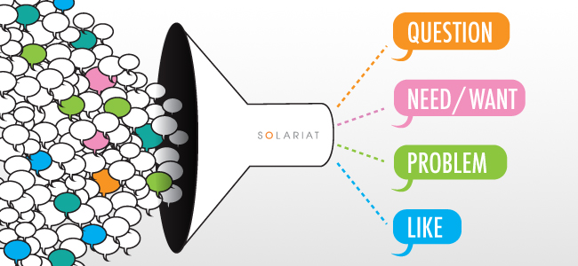
CCBY Derrick Harris, slariat web, https://gigaom.com/wp-content/uploads/sites/1/2012/05/1203_solariat_web_image.jpg?w=300&quality=80&strip=all

  - Although if you want to search them in the Google you can use the advanced search settings to limit the search results to public domain or creative commons. If you do use it, you have to be very careful to check the license carefully, because it's not always reliable, but now that you've learned how to do that, check the attached pics to see where to change the settings:
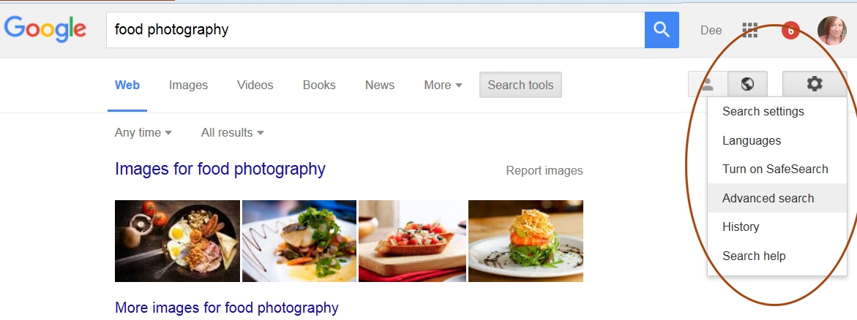
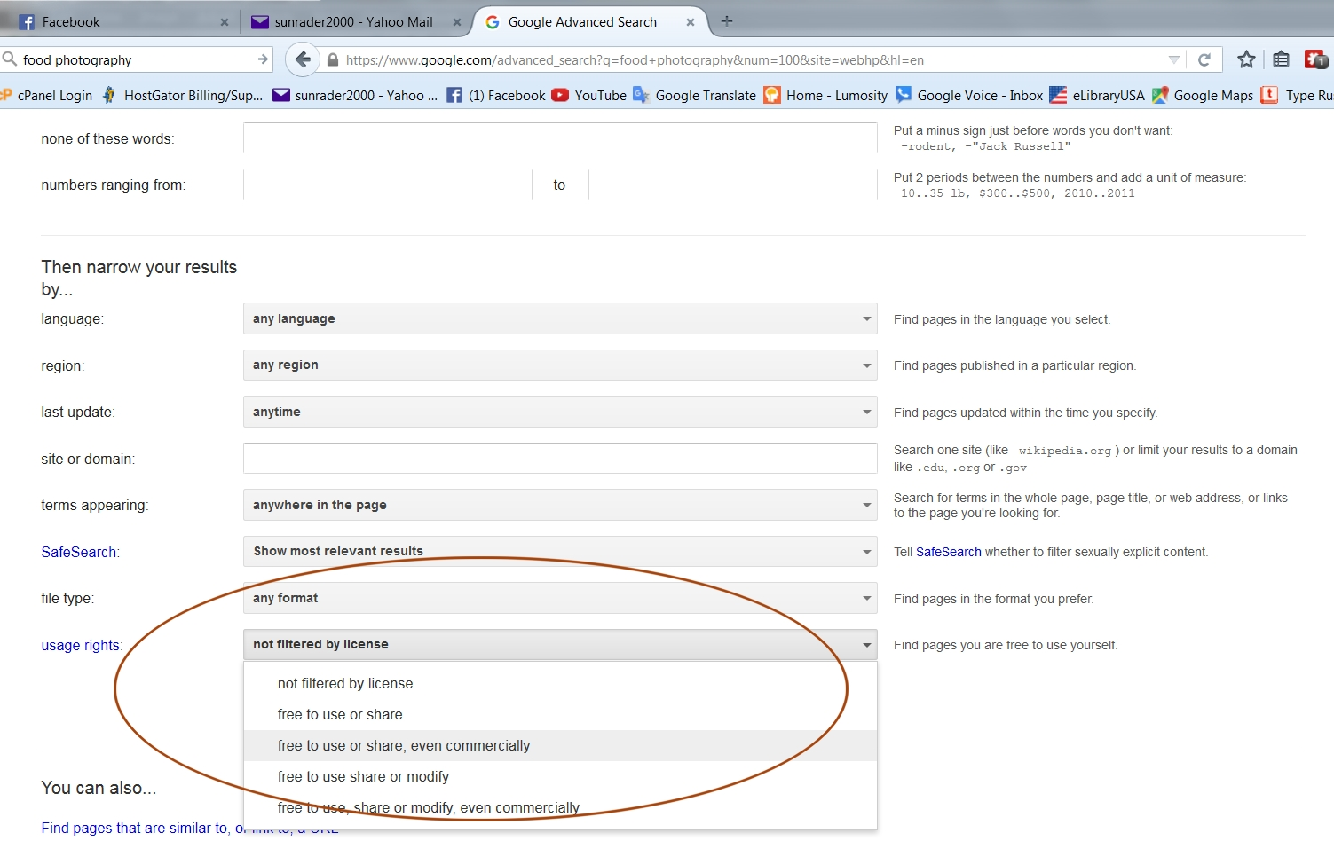
  - Moreover you can also use your own original taken pictures as the author of them.
- Here some websites where you can find free and legal pictures for your activity materials:
http://www.clker.com/
https://www.flickr.com/creativecommons/

Some places to find free listening passages:
Breaking News English: http://www.breakingnewsenglish.com/
BBC: http://www.bbc.co.uk/worldservice/learningenglish/index.shtml
Nursery Rhymes: http://www.eaglesweb.com/Mother_Goose.htm
Podcasts (narration): http://www.eslpod.com/
Podcasts (jokes): http://www.manythings.org/jokes/
Podcasts (links): http://iteslj.org/links/ESL/Listening/Podcasts/

Other Good Sources for Legally Available Material.
http://publicdomainreview.org/
http://gutenberg.org/
http://elibraryusa.state.gov/resources.html
http://www.joshwoodward.com/song/LetItIn
http://etc.usf.edu/lit2go/
http://www.techsupportalert.com/free-books-audio

