RENAISSANCE

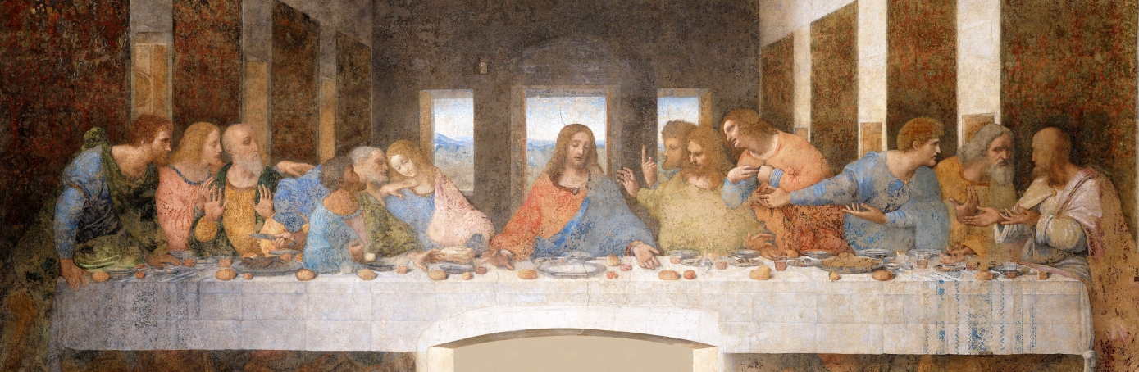

SUBJECT: RISE OF MODERN WEST  
NAME: ROBIN MATHEW  
SEMESTER: 3RD  
YEAR: 2ND YEAR

INTRODUCTION:

The period of European history referred to as **the Renaissance** was a time of great social and cultural change in Europe. Generally speaking, the Renaissance spanned from the 14th to the 16th centuries, spreading across Europe from its birthplace in Italy. For some historians, the European Renaissance is considered as the dawn of the Early Modern Era.

The term 'renaissance' is derived from the French word meaning 'rebirth'. It is used to describe this phase of European history because many of the changes experienced between the 14th and 16th centuries were inspired by a revival of the classical art and intellect of Ancient Greece and Rome. Much of the art, architecture, literature, science and philosophy that surfaced during the Renaissance was so reminiscent of this ancient past, that it seemed as though Europe was indeed reborn during the late Middle Ages.

The history of Europe can be divided into three main ages. These ages are known as the **Classical Age** (also referred to as Ancient Europe), the **Middle Ages** (also referred to as the medieval period) and the **Modern Age**.

BACKGROUND:

"Renaissance" means "rebirth." The traditional application of the term is in many ways misleading, like so many of the traditional Western period designations. It loosely denotes a wave of cultural changes that swept across Europe, beginning in Florence and the surrounding Italian city-states in the fourteenth century and lasting until the middle of the seventeenth century. But today's scholars realize the impossibility of drawing a clear dividing line between the medieval and the Renaissance worlds and reject the traditional connotations of the two terms. For centuries, "medieval" has implied "old-fashioned," while "Renaissance" has been a high compliment suggesting wide-ranging knowledge and ability. Now, however, we recognize fundamental flaws in this apportioning of blame and praise. As the era when the seeds of imperialism and despotism were sown, the Renaissance must not be idealized; nevertheless, although not all were positive, major changes certainly did take place during this long period of time. The scholars and artists whose work constitutes the early stages of the Renaissance were convinced that they had rediscovered classical antiquity, largely because new access to ancient Greek literature enabled them to read Greek texts in the language of their authors rather than in medieval Latin and Arabic translations. Manuscripts in the original Greek came Westward when the Turks conquered Constantinople and its Christian inhabitants in 1453; refugee scholars brought their libraries with them when they fled the Turkish invasion just as refugees in this century who have been forced to relocate bring their learning and cultural traditions to their new homelands.

In Florence, where the age of humanism and the Renaissance began decades before 1453, poets and painters were recording a new view of the universe and of human beings' role in it. The Renaissance humanists believed that ancient Greece and Rome, where "man was the measure of all things" (as the Athenian philosopher Protagoras wrote in the 5th century B.C.), provided models for improving their world. Although they were Christians, the humanists depended on human intelligence rather than divine authority to reform and correct the corrupt practices condemned by critics like Dante.

CAUSES FOR THE RISE OF RENAISSANCE:

**1.** **Decline of Feudalism:**

In the first place the decline of feudalism, which was the basis of life during the medieval period, greatly contributed to the rise of Renaissance. The feudalism which began to decline by the close of the thirteenth century in France and Italy virtually disappeared from Western European countries by the 1500 A.D

**2.** **Impact of the Crusades:**

The Crusades or the wars between the Christians and Muslims which were fought between 11th and 14th century and which ultimately resulted in the victory of the Muslims also provided an impetus to Renaissance. As a result of the Crusades the Western scholars came in contact with the East which was more civilized and polished than the Christians. A number of Western scholars went to the universities of Cairo, Kufa and Cardona etc and learnt many new ideas, which they subsequently spread in Europe

**3.** **Decline in the influence of Church:**

The Church which dominated the medieval society suffered a set back in the thirteenth and fourteenth centuries. The temporal power of the Church was challenged by a number of strong monarchs. In 1296 A.D. King Philip IV of France got the Pope arrested and made him a prisoner. This gave a serious blow to the power and prestige of the Pope. Even the common people lost faith in Church due to rise of numerous rituals. They preferred to pay greater attention to the present life rather than the life after death. No wonder they did not find the medieval ideals of other worldliness and asceticism satisfactory.

**RENAISSANCE IN ITALY:**

The **Italian Renaissance** began the opening phase of the [Renaissance](http://www.newworldencyclopedia.org/entry/Renaissance),

a period of great cultural change and achievement in Europe that spanned the period from the end of the fourteenth century to about 1600, marking the transition between Medieval and Early Modern Europe.

The word *renaissance* in French, (rinascimento in Italian) literally means “rebirth,” and the era is best known for the renewed interest in the culture of classical antiquity following the period that Renaissance humanists labeled the Dark Ages. However, the use of term *renaissance* is modern, not coming into currency in the nineteenth century, in the work of historians such as Jacob Burckhardt.

The Italian Renaissance began in Tuscany, centered in the cities of Florence and Siena. It later had a significant impact in Venice, where the remains of ancient Greek culture provided humanist scholars with new texts. The Italian Renaissance peaked in the late-fifteenth century as foreign invasions plunged the region into turmoil. However, the ideas and ideals of the Renaissance spread into the rest of Europe, setting off the Northern Renaissance centered in Fontainebleau and Antwerp, and the English Renaissance.

The Italian Renaissance is best known for its cultural achievements. They include works of literature by such figures as Petrarch, Castiglione, and Machiavelli; works of art by artists such as Michelangelo and Leonardo da Vinci; and great works of architecture, such as The Duomo in Florence and St. Peters’s Basilica in Rome.

### LITERATURE AND POETRY:

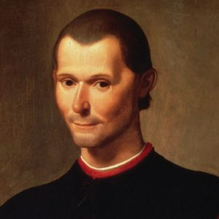

*Niccolò di Bernardo dei Machiavelli was an Italian historian, politician, diplomat, philosopher, humanist, and writer, who is recognized as the founder of modern political science and political ethics*

The thirteenth-century Italian literary revolution helped set the stage for the Renaissance. It was only in the thirteenth century that Italian authors began writing in their native language rather than Latin, French, or Provençal. The 1250s saw a major change in Italian poetry as the *Dolce Stil Novo* (*Sweet New Style*, which emphasized Platonic rather than courtly love) came into its own, pioneered by poets like Guittone d'Arezzo and Guido Guinizelli. Especially in poetry, major changes in Italian literature had been taking place decades before the Renaissance truly began.

Niccolò Machiavelli (1469–1527), the author of *The Prince*  and prototypical Renaissance man. Detail from a portrait by .

With the printing of books initiated in Venice by Aldus Manutius, an increasing number of works began to be published in the Italian vernacular, in addition to the flood of Latin and Greek texts that constituted the mainstream of the Italian Renaissance. The source for these works expanded beyond works of theology and towards the pre-Christian eras of Imperial Rome and Ancient Greece. This is not to say that no religious works were published in this period: Dante Alighieri's *The Divine Comedy* reflects a distinctly medieval worldview. Christianity remained a major influence for artists and authors, with the classics coming into their own as a second primary influence.

In the early Italian Renaissance, much of the focus was on translating and studying classic works from Latin and Greek. Renaissance authors were not content to rest on the laurels of ancient authors, however. Many authors attempted to integrate the methods and styles of the ancient greats into their own works. Among the most emulated Romans are Cicero, Horace, Sallust, and Virgil. Among the Greeks, Aristotle, Homer, and Plato were now being read in the original for the first time since the fourth century, though Greek compositions were few.

The literature and poetry of the Renaissance was also largely influenced by the developing science and philosophy. The humanist Francesco Petrarch, a key figure in the renewed sense of scholarship, was also an accomplished poet, publishing several important works of poetry. He wrote poetry in Latin, notably the Punic War epic *Africa*, but is today remembered for his works in the Italian vernacular, especially the *Canzoniere*, a collection of love sonnets dedicated to his unrequited love Laura. He was the foremost writer of sonnets in Italian, and translations of his work into English by Thomas Wyatt established the sonnet form in that country, where it was employed by William Shakespeare and countless other poets.

Petrarch's disciple, Giovanni Boccaccio, became a major author in his own right. His major work was the *Decameron*, a collection of 100 stories told by ten storytellers who have fled to the outskirts of Florence to escape the black plague over ten nights. The *Decameron* in particular and Boccaccio's work in general, were a major source of inspiration and plots for many English authors in the Renaissance, including Geoffrey Chaucer and William Shakespeare.

Aside from Christianity, classical antiquity, and scholarship, a fourth influence on Renaissance literature was politics. The political philosopher Niccolò Machiavelli's most famous works are *Discourses on Livy*, *Florentine Histories*, and finally *The Prince*, which have become so well-known in Western society that the term "Machiavellian" has come to refer to the *realpolitik* advocated by the book.

**POLITY:**

Renaissance states had three basic forms of government: princedoms, monarchies, and oligarchies, which the Renaissance called republics.

***Princedoms:***A prince was an individual, whether called duke, count, marquis, or just signore (lord), who ruled a state, usually with the support of his family. The term "prince" meant the authority to make decisions concerning all inhabitants without check by representative body, constitution, or court. But the source of the prince's power and the nature of his rule varied greatly. He often had displaced another ruler or city council by force, war, assassination, bribery, diplomacy, purchase, marriage, or occasionally because the city invited him in to quell factionalism. Most often a prince came to power through an adroit combination of several of these. Once in control, he promulgated laws of succession to give himself a cloak of legitimacy so that his son or another family member might succeed him. Indeed, some inhabitants of the state would see him as legitimate and be content to be ruled by him.

***Monarchies:*** A monarchy was a princedom sanctioned by a much longer tradition, stronger institutions, and greater claims of legitimacy for its rulers. The majority of monarchies (for example, England, France, Portugal, Scotland, and Spain) were hereditary, while Poland, Hungary, Bohemia, and the Holy Roman Empire were elective. Monarchies typically were larger than princedoms and ruled subjects speaking multiple languages and dialects. Monarchies usually had developed laws and rules that determined the succession in advance. Only when the succession was broken through the lack of a legitimate heir, a bitter dispute within the ruling family, or overthrow by a foreign power was a monarch displaced by another. Monarchies grew in power and size in the Renaissance. Conflicts between territorial monarchies dominated international politics and war in the Renaissance.

***Republics:***The smallest and most unusual political unit was the city-state consisting of a major town or city and its surrounding territory of farms and villages. Oligarchies, usually drawn from the merchant elite of the town, ruled republics. Flanked by the professional classes, the merchant community first dominated the commerce of the city. Then in the Middle Ages they threw off the authority of prince, king, or emperor. In their place the merchants created a system of government through interlocking and balanced councils. Large deliberative assemblies, comprising of one hundred, two hundred, or more adult males, elected or chosen by lot, debated and created laws. Executive committees, often six, eight, or a dozen men elected for two to six months, put the laws into action.

**PHILOSOPHY:**

Philosophical trends also changed during the Renaissance. New ways of thinking, sparked by a philosophy known as **humanism**, altered the way in which people thought about human beings and the universe. During medieval times, the Catholic Church had been the major force influencing people's thoughts and beliefs on these matters. Unlike the Catholic faith, however, humanism did not promote the notion that humans are naturally sinful and it also placed a lot of emphasis on finding reason.

With the spread of humanistic thought, the medieval emphasis on spirituality was gradually replaced by a focus on the more physical characteristics of humans. The field of study now referred to as the humanities (history, social sciences, the arts, literature and languages) is derived from the term humanism. The philosophical changes which occurred during the Renaissance also paved the way for another shift in thinking that was experienced in Europe at the turn of the Modern Age. This later revolution was known as the **Enlightenment.  
  
HUMANISM:**

In some ways Humanism was not a philosophy but a method of learning. In contrast to the medieval scholastic mode, which focused on resolving contradictions between authors, humanists would study ancient texts in the original, and appraise them through a combination of reasoning and empirical evidence. Humanist education was based on the programme of 'Studia Humanitatis', that being the study of five humanities: poetry, grammar, history, moral philosophy and rhetoric. Although historians have sometimes struggled to define humanism precisely, most have settled on "a middle of the road definition... the movement to recover, interpret, and assimilate the language, literature, learning and values of ancient Greece and Rome”. Above all, humanists asserted "the genius of man ... the unique and extraordinary ability of the human mind"

The humanists believed that it is important to transcend to the afterlife with a perfect mind and body. This transcending belief can be done with education. The purpose of humanism was to create a universal man whose person combined intellectual and physical excellence and who was capable of functioning honorably in virtually any situation.This ideology was referred to as the *uomo universale*, an ancient Greco-Roman ideal. The education during Renaissance was mainly composed of ancient literature and history. It was thought that the classics provided moral instruction and an intensive understanding of human behavior.

**SCIENCE:**

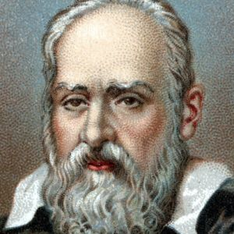

*Galileo Galilei, was an Italian astronomer, physicist, engineer, philosopher, and mathematician who played a major role in the scientific revolution during the Renaissance*

Science and engineering were other fields that experienced major changes during the Renaissance. Many new and exciting discoveries were made, mainly in the areas of anatomy, astronomy and physics. Breakthroughs in engineering also paved the way for many of the world's most significant inventions, such as telescopes, clocks and spectacles. Pioneering Renaissance scientists and inventors included Galileo Galilei and Leonardo da Vinci.

**ARCHITECTURE:**

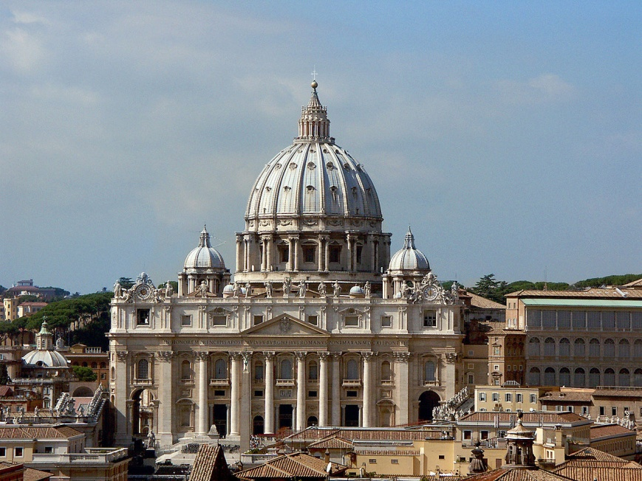

*St. Peter's Basilica: The dome, completed in 1590, was designed by Michelangelo Buonarroti,  
architect, painter and poet.*

In Italy, the Renaissance style, introduced with a revolutionary but incomplete monument in Rimini by Leone Battista Alberti, was developed, however, in Florence. Some of the earliest buildings showing Renaissance characteristics are Filippo Brunelleschi's church of San Lorenzo and the Pazzi Chapel. The interior of *Santo Spirito* expresses a new sense of light, clarity, and spaciousness, which is typical of the early Italian Renaissance. Its architecture reflects the philosophy of Humanism, the enlightenment and clarity of mind as opposed to the darkness and spirituality of the Middle Ages. The revival of classical antiquity can best be illustrated by the Palazzo Ruccelai. Here the pilasters follow the superposition of classical orders, with Doric capitals on the ground floor, Ionic capitals on the *piano nobile* and Corinthian capitals on the uppermost floor.

In Mantua, Leone Battista Alberti ushered in the new antique style, though his culminating work, Sant'Andrea, was not begun until 1472, after the architect's death.

The High Renaissance, as we call the style today, was introduced to Rome with Donato Bramante's Tempietto at San Pietro in Montorio (1502) and his original centrally planned St. Peter's Basilica (1506), which was the most notable architectural commission of the era, influenced by almost all notable Renaissance artists, including Michelangelo and Giacomo della Porta. The beginning of the late Renaissance in 1550 was marked by the development of a new column order by Andrea Palladio. Colossal columns that were two or more stories tall decorated the facades.

### **Sculpture and painting:**

### https://upload.wikimedia.org/wikipedia/commons/9/94/Sanzio_01.jpg

*The School of Athens, or Scuola di Atene in Italian, is one of the most famous frescoes by the Italian Renaissance artist Raphael*

### In painting, the false dawn of Giotto's realism, his fully threedimensional figures occupying a rational space, and his humanist interest in expressing the individual personality rather than the iconic images, was followed by a retreat into conservative late-Gothic conventions. The Italian Renaissance in painting began anew, in Florence and Tuscany, with the frescoes of Masaccio then the panel paintings and frescoes of Piero della Francesca and Paolo Uccello began to enhance the realism of their work by using new techniques in perspective, thus representing three dimensions in two-dimensional art more authentically. Piero della Francesca even wrote treatises on scientific perspective.

The creation of credible space allowed artists to also focus on the  
accurate representation of the human body and on naturalistic landscapes. Masaccio's figures have a plasticity unknown up to that point in time. Compared to the flatness of Gothic painting, his pictures were revolutionary. At the turn of the sixteenth century, especially in Northern Italy, artists also began to use new techniques in the manipulation of light and darkness, such as the tone contrast evident in many of Titian's portraits and the development of sfumato and chiaroscuro by Leonardo da Vinci and Giorgione. The period also saw the first secular (non-religious themes).

In sculpture, Donatello's (1386–1466) study of classical sculpture lead to his development of classicizing positions (such as the contrapposto pose) and subject matter (like the unsupported nude – his second sculpture of David was the first free-standing bronze nude created in Europe since the Roman Empire.) The progress made by Donatello was influential on all who followed; perhaps the greatest of whom is Michelangelo, whose David of 1500 is also a male nude study. Michelangelo's *David* is more naturalistic than Donatello's and has greater emotional intensity. Both sculptures are standing in contrapposto, their weight shifted to one leg.

The period known as the High Renaissance represents the culmination of the goals of the earlier period, namely the accurate representation of figures in space rendered with credible motion and in an appropriately decorous style. The most famous painters from this time period are Leonardo da Vinci, Raphael, and Michelangelo Buonarroti. Their images are among the most widely known works of art in the world. Leonardo's *Last Supper*, Raphael's *School of Athens*, and Michelangelo's *Sistine Chapel Ceiling* are the textbook examples of this period.

Religion:

The new theories were of course seen as radical and revolutionary in a religious perspective. Religion had an important role in people’s lives and the church had until then been the authoritative source of information about heaven and earth. Now its dogmatic position was challenged by new, and what the church would call heretic theories. And indeed, this was a dilemma for many of the physicians and scholars. They were religious people who believed in the Holy Trinity and feared the wrath of God. But their findings and theories were published, and being devoted to their scientific vocation many of them suffered hard persecution from the church and were excommunicated after Inquisition trials. The conflict between science and religion has since then been a significant element in the quest for understanding human nature and life in general. This strife reached a climax two centuries later when Charles Darwin published his “Origin of Species”. The clash between creationism and evolution is even today a hot issue in many communities both in the USA and Europe.

CONCLUSION:

The Renaissance led to significant results. It brought about a transition from the medieval to the modern age. This period witnessed the end of the old and reactionary medieval spirit, and the  
beginning of the new spirit of science, reason and experimentation. The hands of the monarchy were strengthened. People in Europe were tired of feudal anarchy. They looked up to the monarchy to ensure peace and order, political stability and economic prosperity.The culture of the Christian people was enriched. However, the Renaissance weakened the church, which could not occupy the position of unquestioned authority, it had possessed during the medieval period.

The Renaissance gave a great impetus to art, architecture, learning and literature which reached tremendous heights. It also created a reverence for antiquity and a great respect for the ancient Greek and Roman classics.

Further, the Renaissance led to the creation of humanism, and gave a stimulus to the growth of vernacular literature. As a result, the Italian, French, German, Spanish and English languages

blossomed at that time.

The Protestant Reformation movement was also strengthened by the Renaissance. It resulted in far reaching scientific inventions and geographical discoveries. The study of history was made more

critical and scientific owing to the development of a more critical spirit demanding accuracy and the discovery of many historical manuscripts.

BIBLIOGRAPHY AND WEBLIOGRAPHY:

* Wikipedia.com
* Encyclopedia.com
* Europe in Transition - Arvind Sinha