13-AMALIY MASHG’ULOT. TURLI SANOQ SISTEMALARIDA AMALLAR BAJARISH.

. Ingliz tilidagi harflarning kodlashtirilishi.[1]

|  |  |  |  |
| --- | --- | --- | --- |
| *Bitli satr* | *Belgi* | *Bitli satr* | *Belgi* |
| 00000 | A | 10000 | Q |
| 00001 | B | 10001 | R |
| 00010 | C | 10010 | S |
| 00011 | D | 10011 | T |
| 00100 | E | 10100 | U |
| 00101 | F | 10101 | V |
| 00110 | G | 10110 | W |
| 00111 | H | 10111 | X |
| 01000 | I | 11000 | Y |
| 01001 | J | 11001 | Z |
| 01010 | K | 11010 | Foydalanilmaydi |
| 01011 | L | 11011 |
| 01100 | M | 11100 |
| 01101 | N | 11101 |
| 01110 | O | 11110 |
| 01111 | P | 11111 |

Ikkilik sanoq tizimida faqat ikkita son mavjud: 0 va 1. Ikkilik sanoq tizimida qo`shish, ayirish, ko`paytirish va bo`lish amallari quyidagicha bajariladi:

|  |  |  |  |  |
| --- | --- | --- | --- | --- |
| Qo`shish |  | Ayirish |  | Ko`paytirish |
| 0+0=0 |  | 0−0=0 |  | 0*0=0 |
| 0+1=1 |  | 1−0=1 |  | 0*1=0 |
| 1+0=1 |  | 1−1=0 |  | 1*0=0 |
| 1+1=10 |  | 10−1=1 |  | 1*1=1 |

Ikkilik tizimida ba’zi arifmetik amallarning bajarilishini ko`rib chiqamiz.

Topshiriq – 1. 1101012 va 1100112 ning yig`indisini hisoblang.

Yechish.

|  |
| --- |
| 1101012 |
| + |
| 1100112 |
| 11010002 |

Topshiriq – 2. 1011,1012 va 1101,0012 ning yig`indisini hisoblang.

Yechish.

|  |
| --- |
| 1011,1012 |
| + |
| 1101,0012 |
| 11000,1102 |

Topshiriq – 3. 101012 va 10102 ning ayirmasini hisoblang.

Yechish.

|  |
| --- |
| 101012 |
| − |
| 10102 |
| 10112 |

Topshiriq – 4. 1012 va 102 ning ko`paytmasini hisoblang.

Yechish. Ikkilik sanoq tizimida ko`paytirish xuddi o`nlik sanoq tizimdagidek bajariladi, faqat qo`shishda ikkilik tizimdagidek qo`shiladi.

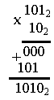

Topshiriq – 5. 101,112 va 11,012 ning ko`paytmasini hisoblang.

Yechish.

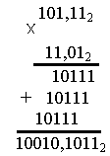

Sonlarni sakkizlik sanoq tizimida yozishda 0 dan 7 gacha bo`lgan sonlardan foydaliniladi. Sakkizlik sanoq tizimidagi barcha amallar shu sakkizta son yordamida bajariladi. Sakkizlik sanoq tizimida qo`shish va ko`paytirish amallari quyidagi jadvallar asosida amalga oshiriladi:

Sakkizlik sanoq tizimida qo`shish jadvali

|  |  |  |  |  |  |  |  |  |
| --- | --- | --- | --- | --- | --- | --- | --- | --- |
| + | 0 | 1 | 2 | 3 | 4 | 5 | 6 | 7 |
| 0 | 0 | 1 | 2 | 3 | 4 | 5 | 6 | 7 |
| 1 | 1 | 2 | 3 | 4 | 5 | 6 | 7 | 10 |
| 2 | 2 | 3 | 4 | 5 | 6 | 7 | 10 | 11 |
| 3 | 3 | 4 | 5 | 6 | 7 | 10 | 11 | 12 |
| 4 | 4 | 5 | 6 | 7 | 10 | 11 | 12 | 13 |
| 5 | 5 | 6 | 7 | 10 | 11 | 12 | 13 | 14 |
| 6 | 6 | 7 | 10 | 11 | 12 | 13 | 14 | 15 |
| 7 | 7 | 10 | 11 | 12 | 13 | 14 | 15 | 16 |

Topshiriq – 6. 367328 va 237248 ning yig`indisi va ayirmasini hisoblang.

Yechish.

|  |  |  |
| --- | --- | --- |
| 367328 |  | 367328 |
| + |  | − |
| 237248 |  | 237248 |
| 626568 |  | 130068 |

Sakkizlik sanoq tizimida ko`paytirish jadvali

|  |  |  |  |  |  |  |  |  |
| --- | --- | --- | --- | --- | --- | --- | --- | --- |
| × | 0 | 1 | 2 | 3 | 4 | 5 | 6 | 7 |
| 0 | 0 | 0 | 0 | 0 | 0 | 0 | 0 | 0 |
| 1 | 0 | 1 | 2 | 3 | 4 | 5 | 6 | 7 |
| 2 | 0 | 2 | 4 | 6 | 10 | 12 | 14 | 16 |
| 3 | 0 | 3 | 6 | 11 | 14 | 17 | 22 | 25 |
| 4 | 0 | 4 | 10 | 14 | 20 | 24 | 30 | 34 |
| 5 | 0 | 5 | 12 | 17 | 24 | 31 | 36 | 43 |
| 6 | 0 | 6 | 14 | 22 | 30 | 36 | 44 | 52 |
| 7 | 0 | 7 | 16 | 25 | 34 | 43 | 52 | 61 |

Topshiriq – 7. 278 va 1468 ning ko`paytmasini hisoblang.

Yechish.

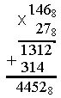

MUSTAQIL BAJARISH UCHUN TOPSHIRIQLAR:

Ikkilik sanoq sistemasida amallarni bajaring:

a) 10010 + 1×27 +1×25 +1×23 +1 × 20 b) 1100 + 1×23 +1 × 21 +1× 2-1 +1 × 2-2

c) 1111,101 + 1 × 23 + 1 × 20 d) 1001,1 × (1 × 24 + 1 × 23 + 1 × 22 + 1 × 21)

e) 1×22+1´21+1´20+1´2-2 +10,001 f) 1 ´ 20+1 ´ 2-1+1 ´ 2-3+1000111

g) 1 ´ 27+1 ´ 23-1,1 h) 11010111-(1 ´ 25+1 ´ 23+1 ´ 2-1)

i) 10101 ´ (1´26+1´24+1´21+1´20) k)1´21+1´20+1´2-2+1´2-4+ 11110,0011

l) 11111,11 : (1 ´ 22+1 ´ 21+1 ´ 2-1) m) (1 ´ 26+1 ´ 24+1 ´ 2-2) :1,101

Bajarilgan amallardan qaysi biri noto‘g‘ri bajarilgan:

|  |  |  |
| --- | --- | --- |
| a) 101-11=11  d) 11 ´ 11=1001  g) 1001-11 =100  k) 11100:11=1001 | b) 111010+10=111100  e) 1010 ´ 1110=10101100  h) 1110,01+1,01=111110  l) 100,101-1,010=11,011 | c)110011,001-1,011=111110,1  f) 11111 ´ 1010=100110110  i)11001,1-110,11=10010,11  m)110100:1101=100 |

Sonlarni taqqoslang.

|  |  |
| --- | --- |
| a) 1101+11 va 1111 +10  c) 11101-11 va 111+11  e) 1101 ´ 1101 va 1011 ´ 1011  g) 111111:11 va 10101 ´ 11  i)111,011´111,1101 va 111,1001´111,101  l)1111+110001 va 11110011-11001 | b) 1001,11+101,01 va 1101,01-101,11  d) 1110,01+101 va 10010,01  f) 1101,011-11,01 va 1011,001  h) 11100111:11 va 1010111:11  k) 1,001001+0,0101 va 1,11101-0,00001  m) 10101 va 1110+111 |

Tenglamalarni ikkilik sanoq sistemasida yeching.

|  |  |
| --- | --- |
| a) x + 1001 = 1000  c) (101 ´ x-100)/10 = (x+10)/100  e) 1101 ´ (x+1101) = x- 10101  g) x10+100 ´ x+100=0  i) x10+101 ´ x+10=0  l) x10-110001=0 | b) (10 ´ x-11) ´ 101= 101101  d) x-(111-x) ´ 11=101 ´ x  f) (1111 ´ x-11)/11 = 101  h) x10 - 10 ´ x+1=0  k) 10 ´ x10+101 ´ x+1=0  m) x10-111 ´ x+1100=0 |

Ifodalarni qiymatini ikkilik sanoq sistemasida va a = 110 va b =101 da hisoblang:

|  |  |
| --- | --- |
| a) (10 ´ a-101 ´ b) ´ 11  c) a10-b10  e) (10 ´ a-b) ´ (10 ´ a+b)  g) a10+10 ´ a ´ b+b10 | b) 101 ´ b-a ´ (100 ´ a+11)  d) a11-1010 ´ a10+b11  f) (1001 ´ b-110 ´ a)/(101 ´ a-110 ´ b+1)  h) a11+101 ´ a10 ´ b+101 ´ a ´ b10 +b11 |

Ikkilik sanoq sistemasida S n = a ´ n + b ketma-ketlikning birinchi beshta hadini yozing:

|  |  |
| --- | --- |
| a) a = 10; b = 11  c) a = 110; b = 101  e) a = 10,1; b = 1,11  g) a = 10,1; b = 101 | b) a = 101; b = 11  d) a = 10; b = 101  f) a = 11,1; b = 11  h) a = 1,01; b = 111 |

To‘g‘ri burchakli uchburchakning asosi va balandligi ikkilik sanoq sistemasida berilgan. Uchburchak yuzini ikkilik sanoq sistemasida toping:

|  |  |
| --- | --- |
| a) a = 101; h = 11  c) a = 101; h = 101  e) a = 111; h = 111  g) a = 101; h = 101 | b) a = 101; h = 110  d) a = 10; h = 101  f) a = 11; h = 11  h) a = 101; h = 111 |

Ikkilik sanoq sistemasida: velosipedchining tezligi V= 10000 km/soat bo‘lsa, 11; 110; 1111 soatdan keyin qancha yo‘l bosib o‘tishini toping.

Sonlar ikkilik sanoq sistemasida qaraladi: qayiq daryo oqimi boylab 1001 km/soat tezlik bilan 10 soat, oqim boylab 101 km/soat tezlik bilan 11 soat suzganda bosib o’tgan yo’lini toping.

Quyidagi amallarni bajaring

Ikkilik sanoq tizimida amallarni bajaring

|  |  |  |  |
| --- | --- | --- | --- |
| 1. | 1112+1012; | 101,112-10,12; | 11,12*1,012; |
| 2. | 101,112+10,1; | 1112-1012; | 10,12*1,012; |
| 3. | 111012+11012; | 100,112-11,12; | 1112*1,0012; |
| 4. | 111012+11012; | 100,112-11,12; | 1112*10,12; |
| 5. | 1110012+11112; | 1000,012-1111,12; | 1,012*1,012; |
| 6. | 101112+11012; | 1001,112-1012; | 1,12*1,112; |
| 7. | 101012+11012; | 101,012-11,12; | 10,12*1,012; |
| 8. | 101112+11012; | 100,012-10,12; | 10,12*10,12; |
| 9. | 10,1112+11,112; | 101112-111,12; | 1,012*11,012; |
| 10. | 1111002+101112; | 100012-1112; | 1112*1012; |
| 11. | 1111,0112+101,112; | 100,112-1,112; | 1,1112*1,012; |
| 12. | 111,012+1012; | 1001,112-111,12; | 1012*1,012; |
| 13. | 101112+111012; | 101,012-0,1112; | 11112*110,12 |
| 14. | 111112+111012; | 1000012-111112; | 10102*1112; |
| 15. | 111012+101112; | 1010012-101112; | 1011­2*11012; |
| 16. | 101112+11112; | 10,0012-10,1112; | 111112*11112; |
| 17. | 111,1112+101012; | 1010112-111112; | 11,01012*112; |
| 18. | 111,11010012+0,11012; | 1001000012-1112; | 1112*11112; |
| 19. | 111112+1110012; | 1101,112-10,00112; | 111,12*1,1012; |
| 20. | 101,112+1000,1012; | 11001112-101112; | 10,12*1,01112; |
| 21. | 11,001012+1101,00012; | 11100,112-1011,1012; | 11112*10,112; |
| 22. | 11,0111012+0,011012; | 10100,112-111,012; | 11112*100,12; |
| 23. | 1110012+11112; | 11000,012-11101,0012; | 1,012*1,01112; |
| 24. | 101112+11111012; | 11001,112-101,11112; | 1,10012*1,112; |
| 25. | 111101012+1101112; | 101,012-11,111112; | 10,1112*1,11012; |

b) Sakkizlik sanoq tizimida amallar bajaring

|  |  |  |  |
| --- | --- | --- | --- |
| 1. | 778+6538; | 6278-3678; | 358*228. |
| 2. | 6778+538; | 7228-3678; | 458*328. |
| 3. | 7658+4538; | 6138-4668; | 1058*228. |
| 4. | 7658+4538; | 6138-4668; | 1058*228 |
| 5. | 6078+6538; | 6028-3678; | 558*768 |
| 6. | 4578+5538; | 5418-4678; | 258*428 |
| 7. | 7658+6538; | 7218-3678; | 228*428 |
| 8. | 5678+5738; | 7018-6678; | 758*528 |
| 9. | 5558+6538; | 5128-4678; | 3058*228 |
| 10. | 6668+6538; | 6028-1678; | 258*428 |
| 11. | 7658+4538; | 6218-4478; | 128*668 |
| 12. | 548+538; | 7218-6678; | 428*2018 |
| 13. | 7778+6538; | 5338-3678; | 458*628 |
| 14. | 7078+6568; | 6448-5578; | 668*328 |
| 15. | 4778+6468; | 5238-4678; | 728*268 |
| 16. | 4768+5378; | 4028-3478; | 578*528. |
| 17. | 5128+5478; | 7008-5218; | 548*378 |
| 18. | 64778+64538; | 602278-443678; | 3158*2528. |
| 19. | 6778+538; | 726528-360478; | 4658*3728. |
| 20. | 763558+457238; | 610038-477668; | 11058*2328. |
| 21. | 760258+454438; | 610038-411668; | 15058*2728 |
| 22. | 6078+655838; | 60728-36078; | 6558*7068 |
| 23. | 414578+5538; | 54128-46578; | 7258*4428 |
| 24. | 76058+65538; | 70218-36378; | 6228*4728 |
| 25. | 56178+572438; | 71018-62678; | 7458*5268 |

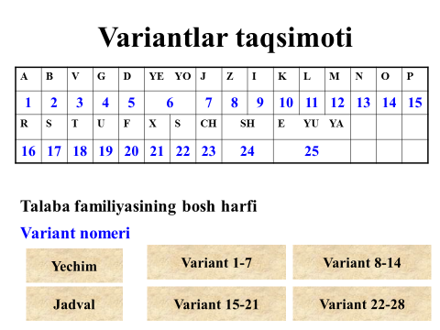 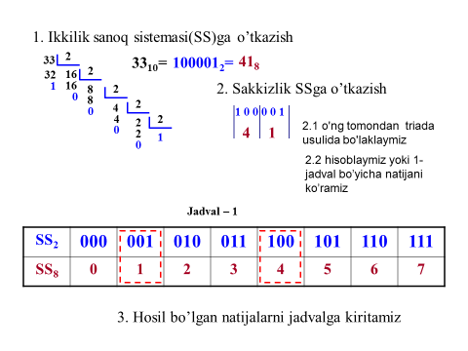

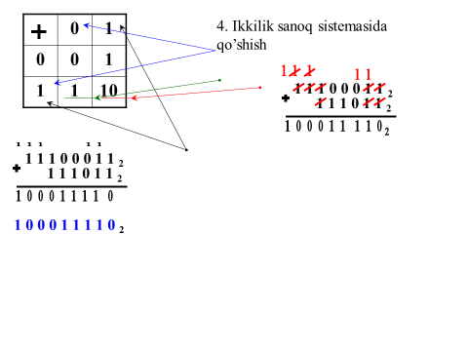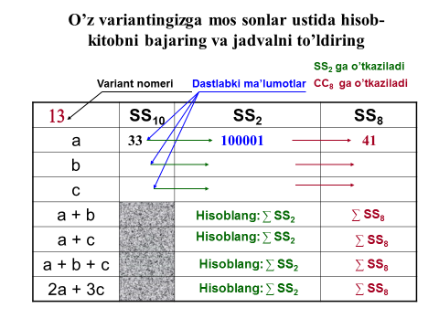

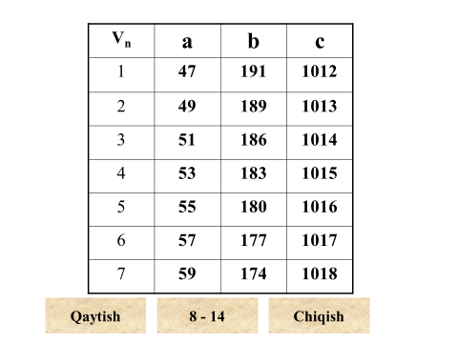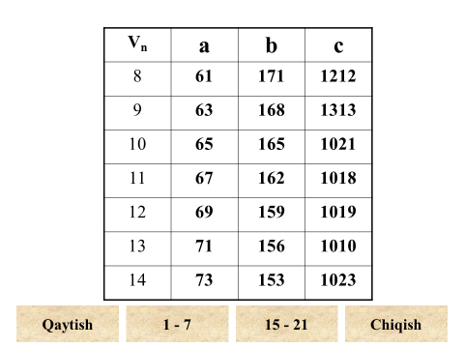

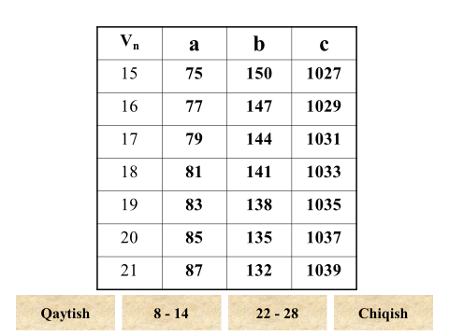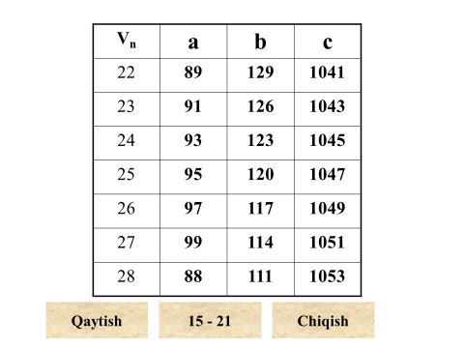

2510 va 5210 sonlarini ikkilik va sakkizlik sanoq sistemalarida ifodalab, so‘ngra ular ustida qo‘shish va ayirish amallarini bajaring.

25,5210 kasr sonini ikkilik va sakkizlik sanoq sistemalarida ifodalab, so‘ngra ular ustida qo‘shish va ayirish amallarini bajaring.

2510 va 5210 hamda 25,5210 kasr sonini o‘n oltilik sanoq sistemasida ifodalab, so‘ngra ular ustida qo‘shish va ko‘paytirish amallarini bajaring.

9. (A+5)10 va (70-A)10 sonlarini ikkilik sanoq sistemasida ifodalab, so‘ngra ular ustida qo‘shish va ayirish amallarini bajaring, bu yerda A – Sizning guruh jurnalidagi familiyangiz tartib raqami.

Quyidagi masalani yeching: Auditoriyada 100 ta talaba bor, shulardan 22 tasi qiz va 23 tasi o‘g‘il bolalar deb aytilsa, qaysi sanoq tizimida keltirilgan. Haqiqiy holda auditoriyada qancha talaba bo‘lgan?

1. Проф. Н.В.Макаровой, В.Б.Волков. Информатика. - М.: 2011 г.(58-с)