**№18 Лаборатория машғулоти**

**Mavzu:Ms Excel dasturida turli sanoq sistemalarda amallar bajarish**

ROMni qoʽllashning muhim jihati oʽzgarmaydigan jadvalni saqlash hisoblanadi. Misol sifatida, raqamli soatlar va kalkulyatorlarda keng qoʽllaniluvchi yetti segmentli displeyning ROM yordamida qanday qilib tuzilganligini koʽrib chiqaylik.

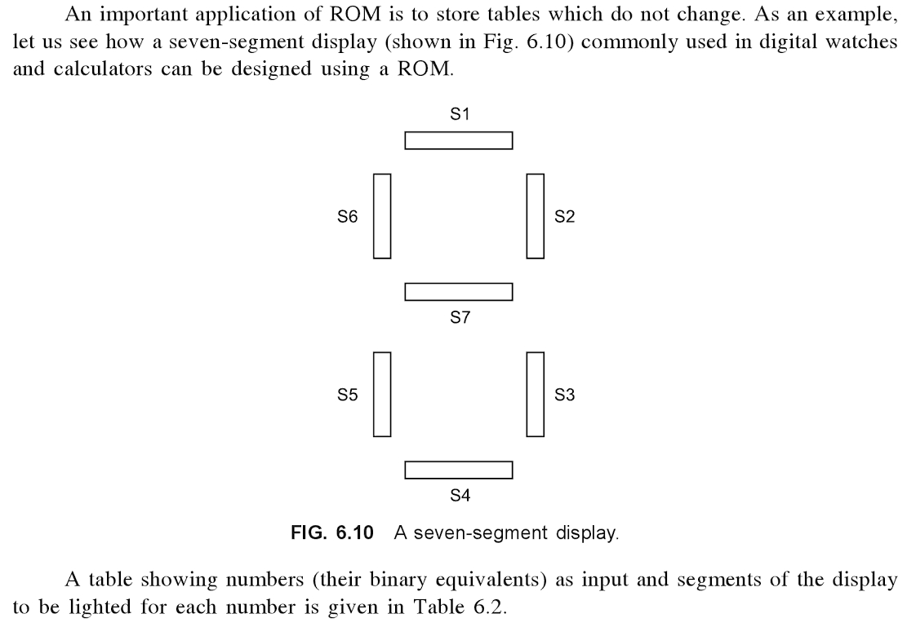

**6.10-rasm.** Yetti segmentli display.

6.2-jadvalda kiritilgan sonlar (ularning ikkilik ekvivalentlari) va har bir sonlarga mos koʽrsatiluvchi segmentlar keltirilgan.

**6.2-jadval.** Yetti segmentli display uchun ROMning tuzilishi.

|  |  |  |  |  |  |  |  |  |
| --- | --- | --- | --- | --- | --- | --- | --- | --- |
| *Raqam* | *Kirish* | *Chiqish segmentlari* | | | | | | |
| S1 | S2 | S3 | S4 | S5 | S6 | S7 |
| 0 | 0000 | 1 | 1 | 1 | 1 | 1 | 1 | 0 |
| 1 | 0001 | 0 | 1 | 1 | 0 | 0 | 0 | 0 |
| 2 | 0010 | 1 | 1 | 0 | 1 | 1 | 0 | 1 |
| 3 | 0011 | 1 | 1 | 1 | 1 | 0 | 0 | 1 |
| 4 | 0100 | 0 | 1 | 1 | 0 | 0 | 1 | 1 |
| 5 | 0101 | 1 | 0 | 1 | 1 | 0 | 1 | 1 |
| 6 | 0110 | 0 | 0 | 1 | 1 | 1 | 1 | 1 |
| 7 | 0111 | 1 | 1 | 1 | 0 | 0 | 0 | 0 |
| 8 | 1000 | 1 | 1 | 1 | 1 | 1 | 1 | 1 |
| 9 | 1001 | 1 | 1 | 1 | 1 | 0 | 1 | 1 |

S1, S2, S3, S4, S5, S6, S7 segmentlar (yorugʽlik moslamasi, qurilma) boʽlib, qaysiki yo yonuvchi yoki yonmasligi mumkin.

Keling, 6.2-jadvalning 1 chizigʽini koʽrib chiqamiz. Qachonki kirish 0 boʽlsa, yetti-segment displeydagi S7 dan tashqari barcha chiroqlar yonishi kerak. Bunda yonishi kerak boʽlgan segment uchun 1 qoʽyib, qorong'i boʽlib qolishi kerak boʽlgan segment 0 qoʽyish orqali koʽrsatilgan. Ushbu jadval ROM da saqlanishi mumkin. Raqamlarga mos keladigan ROM ning MAR da joylashgan 4 bit koʽrsatilsa, yetti bitga mos S1, S2, S3 ..., S7 MDR da paydo boʽladi. Bu bit tegishli lampalarni yoritish uchun ishlatiladi. Misol uchun, biz, 0 1 0 1 ni MAR ga joylashtirsak, chiqish bit S1 = 1, S2 = 0, S3 = 1, S4 = 1, S5 = 0, S6 = 1, S7 (soni 5 mos) boʽladi. Shunday qilib segmentlar S1, S3, S4, S6 va S7 shakl 6.11, va 5 da koʽsatilgandek yonadi.

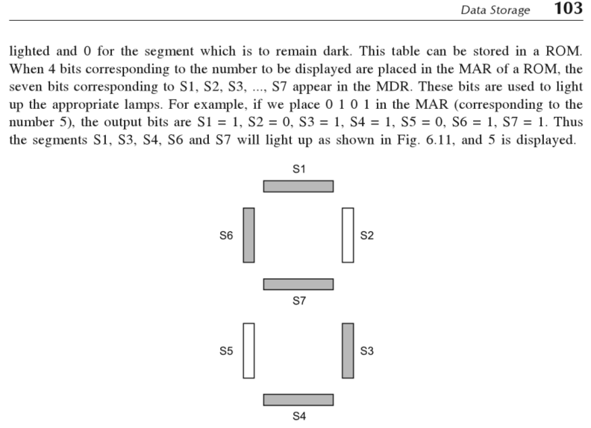

**6.11-rasm.** Yetti segmentli displayda 5 raqamini koʽrsatish[1].

*Uslubiy ko’rsatma:* Misol: Berilgan 104 sonini 2 lik, 8 lik va 16 lik sanoq sistemasiga o'tkazing.

Bajarish:

1. 2 lik sanoq sistemasiga o'tkazish

|  |  |  |  |  |  |  |
| --- | --- | --- | --- | --- | --- | --- |
| 104  -104 | 2 | 2 | |  | | 2 |
| 52  52 |
| 0 | 26  26 | 2 |
| 0 | 13  12 | 2 | |
|  | 6  6 | 2 |
| 3  2 |
| 0 | 1 |

Demak l0410=11010002

Buni Ms Excel dasturi yordamida quiydagicha bajariladi:

MS Excel dasturini ishga tushirib A1 yachekaga 104 soni yoziladi va Формулы menyusidan funktsiyalar kutubxonasi bo’limidan foydalanamiz.

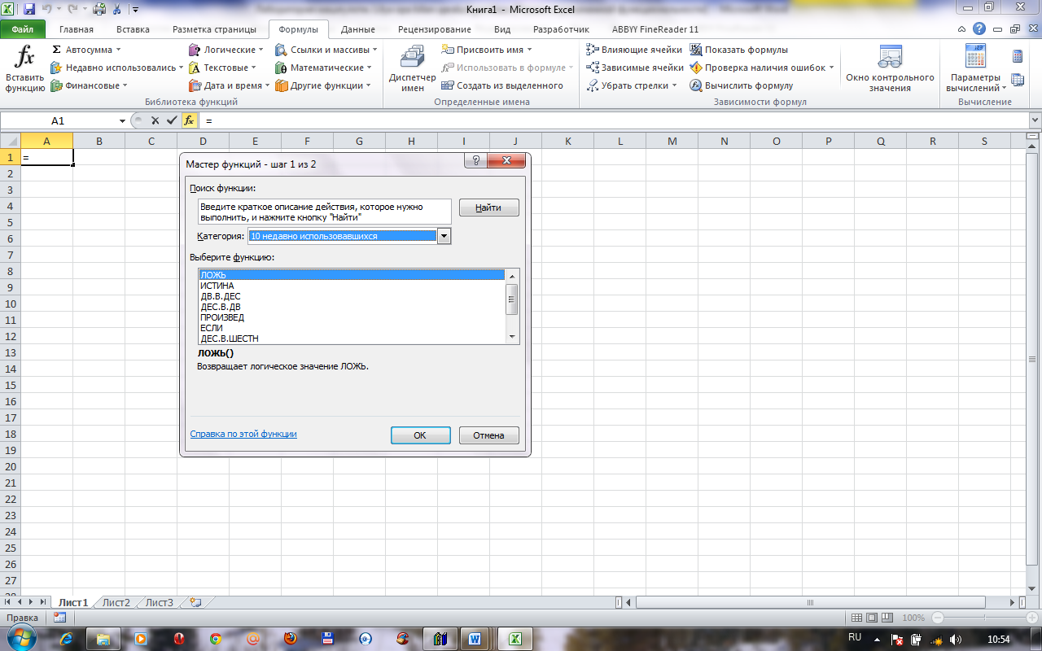

So’ng, Другие функции qatoridan инженерные – дес.в.дв tanlansa o’nlikda berilgan 104 soni ikkilikda 1101000 soniga o’tadi. (qolgan sonlar ham shu tariqa o’tiladi)

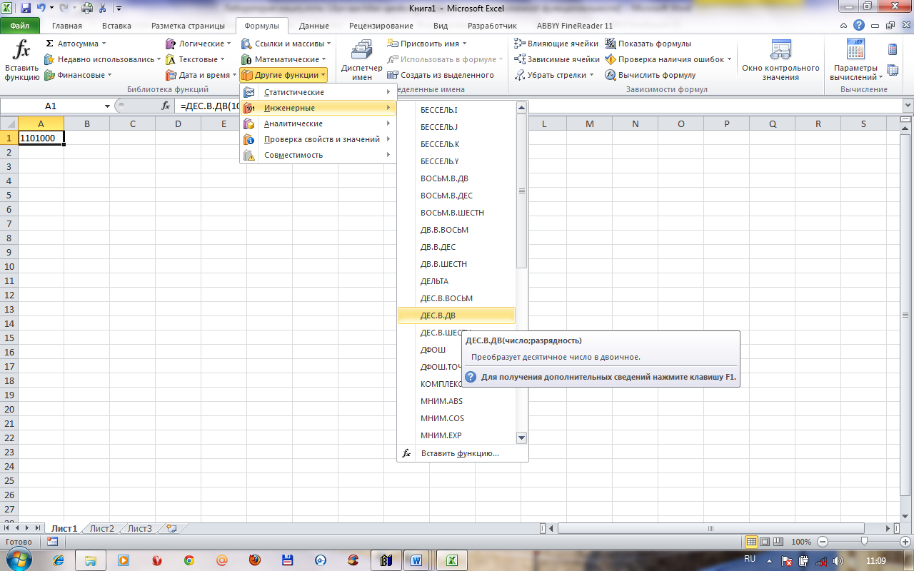

b) 81ik sanoq sistemasiga o'tkazish:

|  |  |  |  |  |  |
| --- | --- | --- | --- | --- | --- |
| 104  -104 | 8 | 8 |  | |  |
| 13  8 |
| 0 | 1 |
| 5 |  | |
|  |  |

Demak 10410=1508

v) 16 lik sanoq sistemasiga o'tkazish

|  |  |  |  |  |  |
| --- | --- | --- | --- | --- | --- |
| 104  -  96 | 16 |  |  | |  |
| 6 |
| 8 |
|  | |
|  |  |

Demak 10410=6816

Misol-2:

a)2 lik sanoq sistemasida berilgan sonlarni 10 lik sanoq sistemasiga o'tkazing.

1) 1101112=l·25+l·24+0·23+1·22+l·21+1·20=32+16+4+2+l=5510

2) 1101,1012=l·23+l·22+0·21+l·2°+1·2-1+0·2-2+l·2-3=8+4+l+1/2+1/8=

8+4+0+1+0,5+0,125=13,625

b) 8 lik sanoq sistemasida berilgan sonlarni 10 lik sanoq sistemasiga o'tkazing.

1. 1178=l·82+l·81+7·80=64+8+7=7910
2. 35,248=3·81+5·8°+2·8-1+4·8-2=24+5+2/8+4/64 =29+0,25+0,0625=29,312

v) 16 lik sanoq sistemasida berilgan sonni 10 lik sanoq sistemasiga o'tkazing.

1) lD,53316=l·161+D·16°+5·161-+3·16-2+3·16-3=16+13+5/16+3/256+3/4096=

=29+0,3125+0,0117+0,0007=29,3249

**Топшириқлар: (Ms Excel dasturi yordamida natijani tekshirib ko’ring)**

1. O'nlik sanoq sistemasida berilgan sonlami a) 2 lik, b) 8 lik, v) 16 lik sanoq sistemasiga o'tkazing

|  |  |  |  |
| --- | --- | --- | --- |
| Variant № | Sonlar | Variant № | Sonlar |
|  | 143 | 16 | 205 |
|  | 144 | 17 | 208 |
| 3. | 159 | 18 | 210 |
| 4. | 160 | 19 | 155 |
| 5. | 163 | 20 | 148 |
| 6. | 170 | 21 | 157 |
| 7. | 200 | 22 | 165 |
| 8. | 250 | 23 | 179 |
| 9. | 180 | 24 | 187 |
| 10. | 189 | 25 | 215 |
| 11. | 190 | 26 | 220 |
| 12. | 195 | 27 | 217 |
| 13. | 177 | 28 | 230 |
| 14. | 183 | 29 | 305 |
| 15. | 197 | 30 | 324 |

1. a) 2 lik, b) 8 lik, sanoq sistemasida berilgan sonlami 10 lik sanoq sistemasiga o'tkazing.

**2 lik sanoq sistemasi**

|  |  |  |  |  |  |  |
| --- | --- | --- | --- | --- | --- | --- |
| Variant № | | Sonlar | | Variant № | | Sonlar |
| 1 | | 10101,11 | | 16 | | 11111,11 |
| 2 | | 11011,10 | | 17 | | 10100,11 |
| 3 | | 11001,11 | | 18 | | 11011,10 |
| 4 | | 11110,10 | | 19 | | 11101,11 |
| 5 | | 111111,01 | | 20 | | 10111,101 |
| 6 | | 10101,001 | | 21 | | 1001001,11 |
| 7 | | 11001,11 | | 22 | | 101000,101 |
| 8 | 100001,100 | | 23 | | 11000,10 | | |
| 9 | 100000,10 | | 24 | | 111111,1101 | | |
| 10 | 11101,10 | | 25 | | 10101,11 | | |
| 11 | 11100,101 | | 26 | | 1010101,101 | | |
| 12 | 100011,101 | | 27 | | 1110001,001 | | |
| 13 | 100111,111 | | 28 | | 1001111,101 | | |
| 14 | 111100,001 | | 29 | | 1110000,100 | | |
| 15 | 1001111,11 | | 30 | | 101010,101 | | |

**8 lik sanoq sistemasi**

|  |  |  |  |  |  |  |
| --- | --- | --- | --- | --- | --- | --- |
| Variant № | | Sonlar | | Variant № | | Sonlar |
| 1 | | 143,56 | | 16 | | 205,12 |
| 2 | | 144,23 | | 17 | | 207,13 |
| 3 | | 152,76 | | 18 | | 210,15. |
| 4 | | 160,34 | | 19 | | 155,16 |
| 5 | | 163,14 | | 20 | | Л46,27; |
| 6 | | 170,47 | | 21 | | 157,26 |
| 7 | | 200,45 | | 22 | | 165,24;. |
| 8 | 250,36 | | 23 | | 176,25 | | |
| 9 | 170,45 | | 24 | | 175,31 | | |
| 10 | 156,27 | | 25 | | 215,32 | | |
| 11 | 146,37 | | 26 | | 220, 33 | | |
| 12 | 147,35 | | 27 | | 217,34 | | |
| 13 | 177,32 | | 28 | | 230,35 | | |
| 14 | 176,33 | | 29 | | 305,36 | | |
| 15 | 172,45 | | 30 | | 324,37 | | |

**Foydalaniladigan adabiyotlar ro‘yxati:**

1. V. Rajaraman. Introduction to information technology (second edition). India, 2013.
2. M.T.Azimjanova, Muradova, M.Pazilova. Informatika va axborot texnologiyalari. O‘quv qo‘llanma. T.: “O‘zbekiston faylasuflari milliy jamiyati”, 2013 y.
3. M.Aripov, M.Muhammadiyev. Informatika, informasion texnologiyalar. Darslik. T.: TDYuI, 2004 y.
4. Sattorov A. Informatika va axborot texnologiyalari. Darslik. Т.:, “O‘qituvchi”, 2011 y.
5. http://[www.informatic.ru](http://www.informatic.ru)
6. <http://www.cs.ifmo.ru/docs/case/>

1. V. Rajaraman, Introduction to Information technology (second edition), PHI Learing Private Limited, India 2013 y. 170 p