**№18. Лаборатория машғулоти**

**Mavzu: MS Excel dasturida turli sanoq sistemalarda amallar bajarish**

**2.11–misol.** (23)10 soniga ekvivalent boʽlgan ikkilikdagi sonni toping.

|  |  |  |  |  |  |
| --- | --- | --- | --- | --- | --- |
| *Yechish*: | 2 | 23 | qoldiq | |  |
|  | 2 | 11 | 1 |  | kichik bit |
|  | 2 | 5 | 1 |  |  |
|  | 2 | 2 | 1 |  |  |
|  | 2 | 1 | 0 |  |  |
|  |  | 0 | 1 |  | katta bit |
|  |  |  | (23)10=(10111)2 | | |

**2.12–misol.** (36)10 soniga ekvivalent boʽlgan ikkilikdagi sonni toping.

|  |  |  |  |  |  |
| --- | --- | --- | --- | --- | --- |
| *Yechish*: | 2 | 36 | qoldiq | |  |
|  | 2 | 18 | 0 |  | kichik bit |
|  | 2 | 9 | 0 |  |  |
|  | 2 | 4 | 1 |  |  |
|  | 2 | 2 | 0 |  |  |
|  | 2 | 1 | 0 |  |  |
|  |  | 0 | 1 |  | katta bit |
|  |  |  | (36)10=(100100)2 | | |

Oʽnlik kasrlarni ham ikkilik sanoq tizimiga oʽtkazish mumkin. Bu usul oʽnlik kasrni ikkining manfiy darajalari yigʽindisi kabi ifodalanishiga asoslangan. Kasrni 2 ga koʽpaytirish ketma-ketligi orqali 2 ning manfiy darajalari koeffitsientini olamiz.

**2.13–misol.** 0.8125 soniga ekvivalent boʽlgan ikkilikdagi sonni toping.

Yechish:

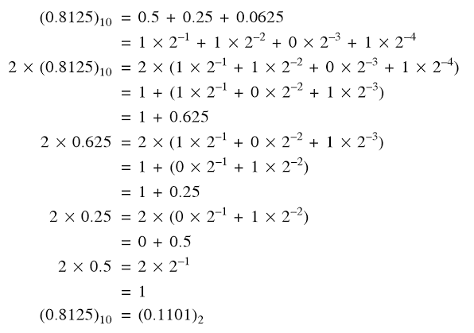

Demak, 

**2.14–misol.** (0,5625)10 sonini ikkilik sanoq tizimiga oʽtkazing:

|  |  |  |  |  |  |  |
| --- | --- | --- | --- | --- | --- | --- |
| **Son** |  |  | *Sonning butun qismi* | |  |  |
| 0.5625 | = | 1.125 | 1 |  | katta bit |
| 0.125 | = | 0.25 | 0 |  |  |
| 0.25 | = | 0.5 | 0 |  |  |
| 0.5 | = | 1.0 | 1 |  | kichik bit |
|  |  | Demak: | (0.5625)10=(0.1001)2 | | |

**2.15–misol**. (0,3)10 soniga ekvivalent boʽlgan ikkilikdagi sonni toping.

*Yechish*:

|  |  |  |  |  |  |
| --- | --- | --- | --- | --- | --- |
| **Son** |  |  | *Sonning butun qismi* | | |
| 0.3 | = | 0.6 | 0 |  | Katta bit |
| 0.6 | = | 1.2 | 1 |  |  |
| 0.2 | = | 0.4 | 0 |  |  |
| 0.42 | = | 0.8 | 0 |  |  |
| 0.8 | = | 1.6 | 1 |  |  |
| 0.62 | = | 1.2 | 1 |  | Davriy takrorlanish qismi |
|  |  | Demak: | (0.3)10=(0.01001(1001))2 | | |

**2.16–misol.** Belbogʽning narhi 125.25 soʽm. Uning ikkilik sanoq tizimidagi narhi qanday boʽladi?

|  |  |  |  |  |  |
| --- | --- | --- | --- | --- | --- |
| Yechish: | 2 | 125 | Qoldiq | |  |
|  | 2 | 62 | 1 |  | kichik bit |
|  | 2 | 31 | 0 |  |  |
|  | 2 | 15 | 1 |  |  |
|  | 2 | 7 | 1 |  |  |
|  | 2 | 3 | 1 |  |  |
|  | 2 | 1 | 1 |  |  |
|  |  | 0 | 1 |  | katta bit |
|  |  |  | (125)10=(1111101)2 | | |

0.25 sonining ikkilik sanoq tizimiga oʽtkazilishi quyidagicha boʽladi:

|  |  |  |  |  |  |
| --- | --- | --- | --- | --- | --- |
| **Son** |  |  | *Sonning butun qismi* | |  |
| 0.25 | = | 1.125 | 0 |  | Ahamiyatli katta bit |
| 0.5 | = | 0.25 | 1 |  |  |
| 0.0 | = | 0.5 | 0 |  |  |
| (0.25) | = | 0.01 |  |  |  |
|  |  | Demak: | 125.2510=1111101.012[1] | | |

1-ish: amallarni bajaring:

a)101,01112+1011,11112b)110,10112-101,01112v)11,012x10,12bajarish: 2lik sanoq sistemasida amallarni bajarish uchun MS Excel dasturini ishga tushirib A1 yachekaga 1-element 10101112 va 2-element 101111112 A2 yachekaga kiritiladi. Funktsiyalar ustasi (мастер функция)dan foydalanamiz. Buning uchun Формулы menyusidan funktsiyalar kutubxonasi bo’limidan foydalanamiz.

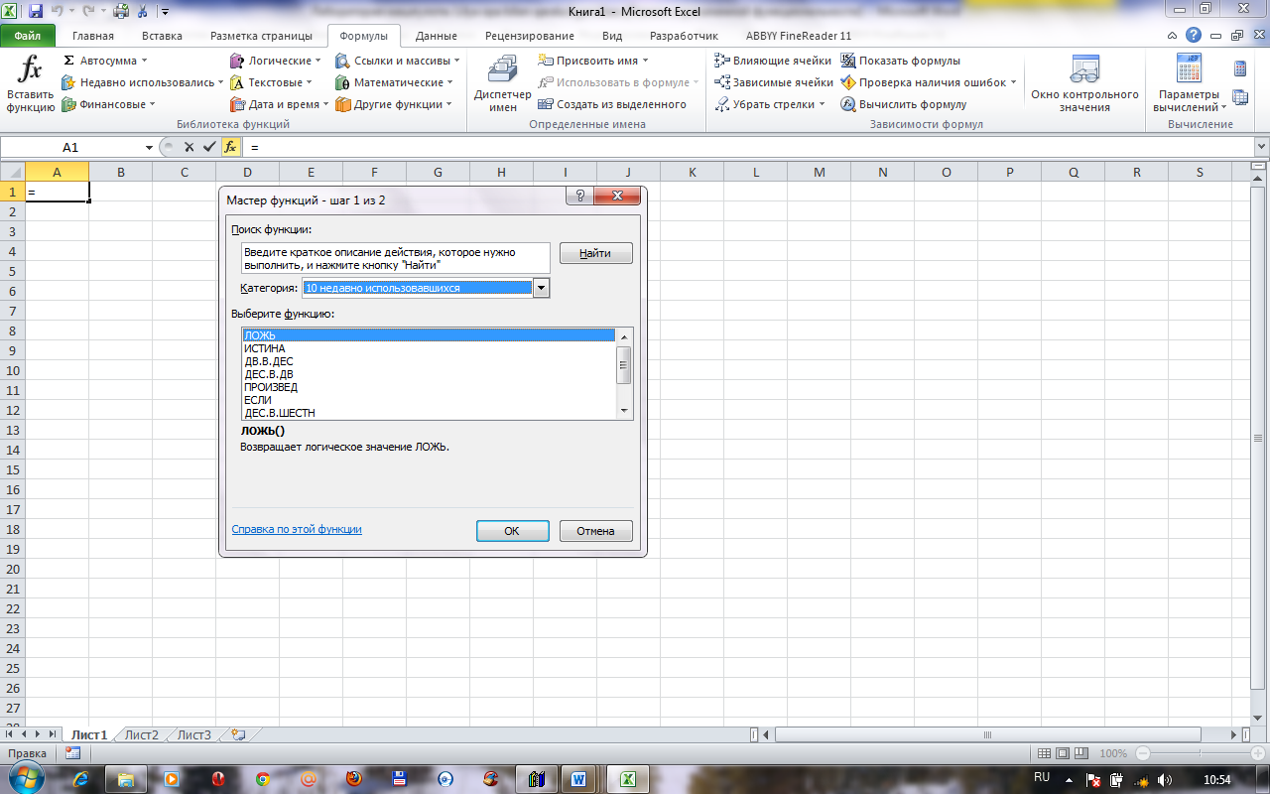

So’ng, Другие функции qatoridan инженерные bo’limidan oldingi laboratoriya mashg’ulotlari singari foydalaniladi.

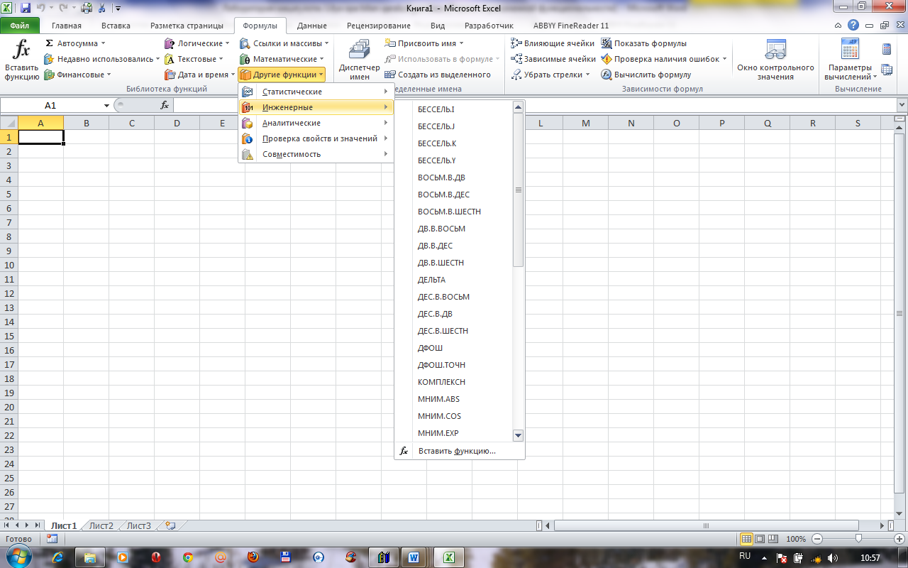

*Uslubiy ko’rsatma:* 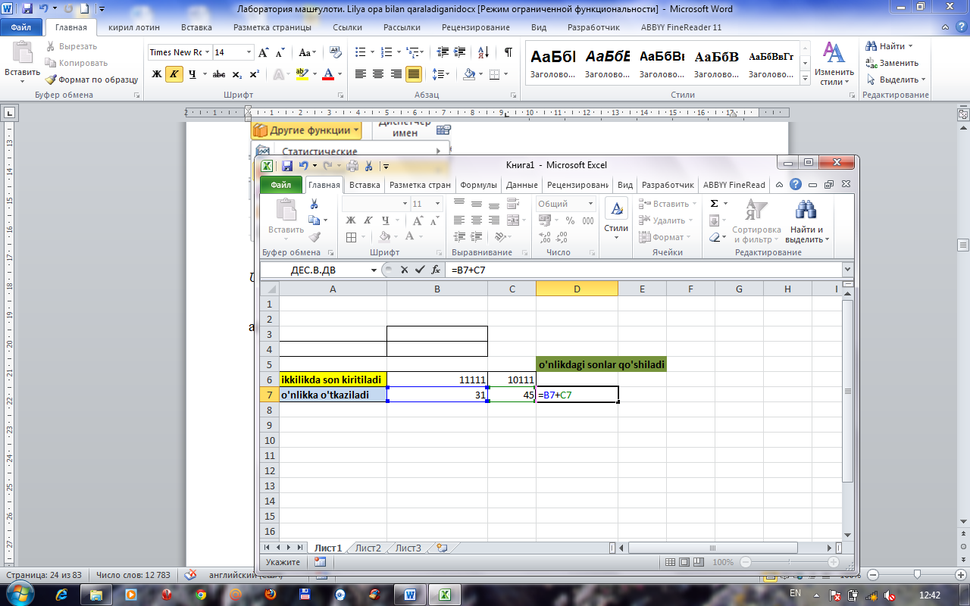

Natijani ikkilikka o’tkaziladi

|  |  |  |  |  |
| --- | --- | --- | --- | --- |
|  |  |  | **o'nlikdagi sonlar qo'shiladi** | **ikkilikka o'tkaziladi** |
| **ikkilikda son kiritiladi** | 11111 | 10111 |  |  |
| o'nlikka o'tkaziladi | 31 | 45 | 76 | 1001100 |

shu tariqa qolgan arifmetik ammallar ham bajariladi.

a) 1011,11112 b) 1110,10112 v) 11,01

+ 101,01112 -101,01112 x10,1

10001,01102 1001,01002 + 1101

1101

1000,001

**Nazorat topshiriqlari variantlari**

I. Sanoq sistemalari ustida amallarni bajaring:

1. a)11112+100102=

b) 5A16·3,516=

2. a)1101,1012+10,1112=  
b) AAA16-77716=

3. a) 10002-11,112=

b) A3716+3316 =

4. a) 110,12-11,012=

b) 7778+6668=

1. a) 35,38-22,48=

b) 7778-5678=

1. a) 1012-1102=

b) 3278+5448=

7. a)110,ll2+lll,l2=

b) 579,E16+37A,D16=

8. a)1101,ll2-10,l2=

b) 1AC,3F]6+FF,3C16=

9. a) 1111,012-11,112=

b) 1CAB,37I6-234,A16=

1. a) 111,1012+101,12=

b) 26408-238=

1. a) 11,12 ·10,12 =

b) 3478+2668=

1. a) 1012 ·1002=

b) 256,678+3278=

1. a) 12A16+AA16=

b) 3,078+l,778=

1. a) AB,BA16+BA,AB16=

b) 32,l8-7,528=

15.a) FF,FF16-77,6916=

b) 247,158+ 177,548=

1. a) 1258-478=

b)1110,10112+101,0112

1. a) 101112 ·1012=

b)23,48-12,28=

1. a)111,112·10,112=

b) 363,328+23,78=

1. a)1011,112-101,1012=

b) 4468+5558=

1. a) 1011,112-101,1012=

b) 278·178=

1. a) 101012+111,112=

b) FF,F16+77,38=

1. a)10112+7128=

b) ACA16-CCC16

1. a)10112+7128=

b)15510-1558=

1. а) 11012+2148=

b) 10012+1778=

1. а) 111,1112+777,7778=

b) 99910-7778 =

26. a) 25510 -3778=

b)15010+1508=

27. а) 89,216+А9,Е16=

b) 703,468-442,78=

28. а)10101,112+111111,112=

b)123,7738-113,2378=

29. а) 10101,102-111,112=

b)15AF,5E16+12AE,C216=

30. а) 11000,112+11011,102=

b) 176,2348+154,3528=

Variantlar:

|  |  |  |  |  |  |  |  |  |  |  |  |  |  |  |  |
| --- | --- | --- | --- | --- | --- | --- | --- | --- | --- | --- | --- | --- | --- | --- | --- |
| № | 1 | 2 | 3 | 4 | 5 | 6 | 7 | 8 | 9 | 10 | 11 | 12 | 13 | 14 | 15 |
| № | 1  16 | 2  17 | 3  18 | 4  19 | 5  20 | 6  21 | 7  22 | 8  23 | 9  24 | 10  25 | 11  26 | 12  27 | 13  28 | 14  29 | 15  30 |

**Foydalaniladigan adabiyotlar ro‘yxati:**

1. V. Rajaraman. Introduction to information technology (second edition). India, 2013.
2. M.T.Azimjanova, Muradova, M.Pazilova. Informatika va axborot texnologiyalari. O‘quv qo‘llanma. T.: “O‘zbekiston faylasuflari milliy jamiyati”, 2013 y.
3. M.Aripov, M.Muhammadiyev. Informatika, informasion texnologiyalar. Darslik. T.: TDYuI, 2004 y.
4. Sattorov A. Informatika va axborot texnologiyalari. Darslik. Т.:, “O‘qituvchi”, 2011 y.

**Elektron ta’lim resurslari**

1. www. pedagog. uz
2. www. Ziyonet. uz
3. www. edu. uz
4. <http://www.ctc.msiu.ru/materials/Book1,2/index1.html>
5. <http://www.ctc.msiu.ru/materials/CS_Book/A5_book.tgz>
6. <http://www.cs.ifmo.ru/docs/case/>
7. http://[www.informic.ru](http://www.informic.ru)
8. http://[www.informaty.ru](http://www.informaty.ru)
9. http://[www.informatika.ru](http://www.informatika.ru)

1. V. Rajaraman, Introduction to Information technology (second edition), PHI Learing Private Limited, India 2013 y. 56 p