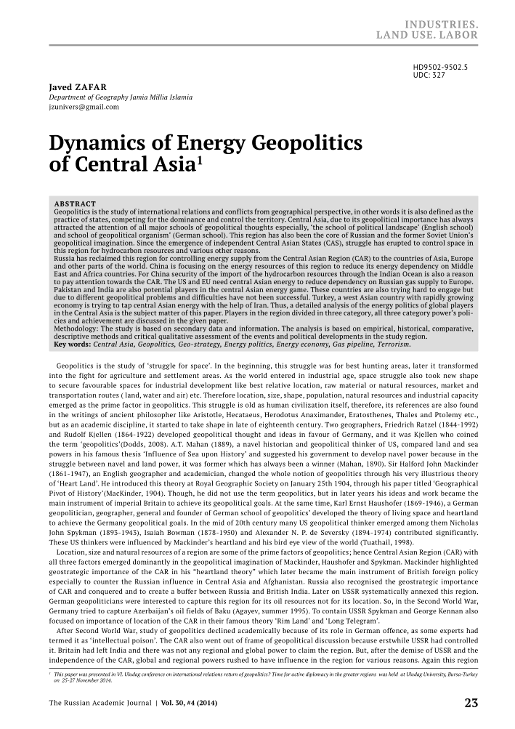

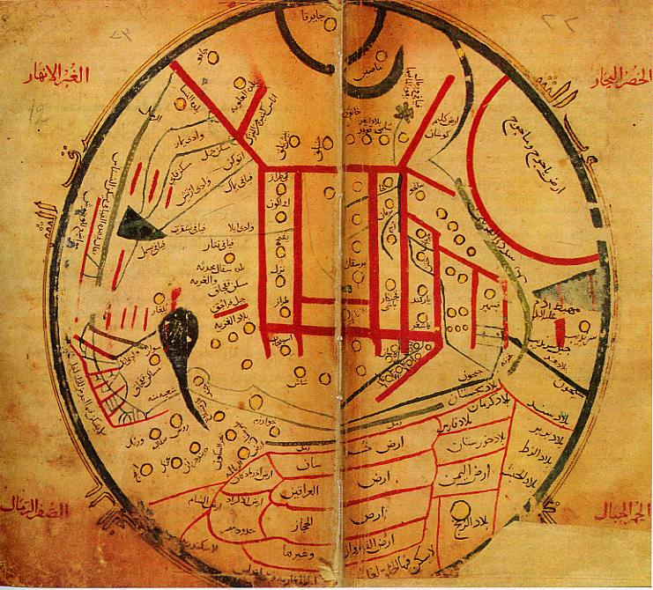

Mahmud Qashg‘ariyning «Devonu lug‘atit-turk» asarida XI asrda turkiy xalqlarning tarqalish xaritasi.

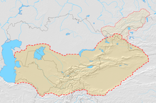

Turkiston xaritasi

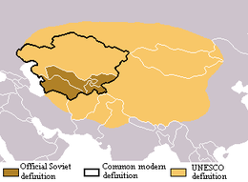

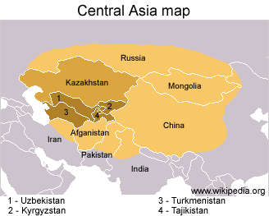

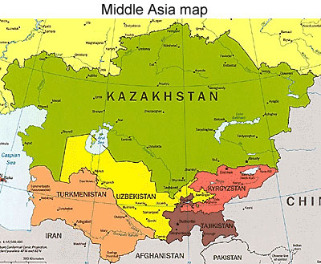

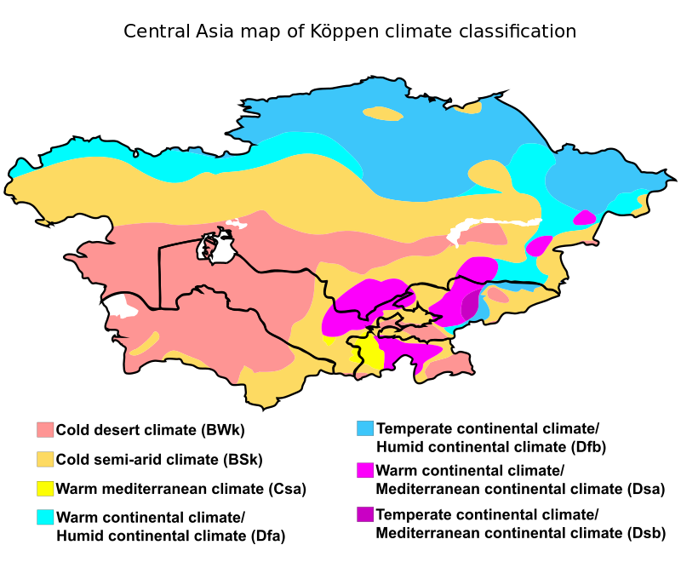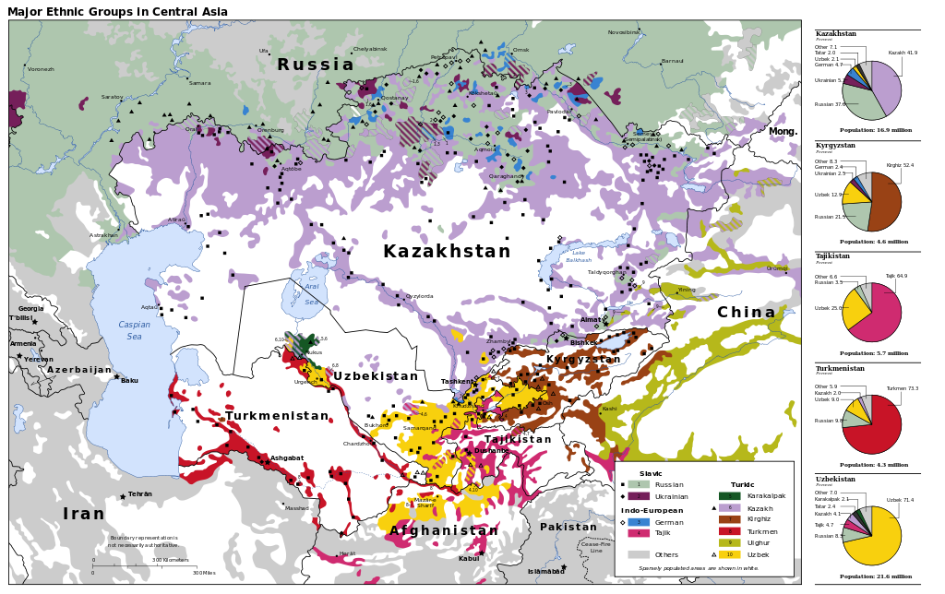

The ethnolinguistic patchwork of Central Asia

|  |  |  |  |
| --- | --- | --- | --- |
| т/р | Tog‘lar nomi | Cho‘qqilar nomi | Balandligi(m) |
| *1* | *Qorjantog‘ tizmasi* | *Mingbuloq* | *2837* |
| *2* | *Ugom tizmasi* | *Sayram* | *4229* |
| *3* | *Piskom tizmasi* | *Beshtor* | *1299* |
| *4* | *Ko‘ksuv tizmasi* |  | *4216* |
| *5* | *Talas Olatog‘ tiz-si* | *Manas* | *4488* |
| *6* | *Chotqol tizmasi* | *Katta Chimyon* | *3309* |
| *7* | *Qizilnura* | *Qizilnura* | *3267* |
| *8* | *Turkiston tizmasi* | *Shovqirtog‘* | *4033* |
| *9* | *Chumqortog‘* | *Bozorxonim* | *3105* |
| *10* | *Nurota tizmasi* | *Hayotboshi (Zargar)* | *2165* |
| *11* | *Oqtog‘* | *Taxnu* | *2005* |
| *12* | *Chaqalikalon* | *Zebon* | *2336* |
| *13* | *Qoratepa* | *Kamqo‘ton* | *2195* |
| *14* | *Zirabuloq* | *Zindontog‘* | *1116* |
| *15* | *Hisor tizmasi* | *Hazrati Sulton* | *4648* |
| *16* | *Chaqchar* | *Xuroson* | *3744* |
| *17* | *Boysun tizmasi* | *Xo‘japiryax* | *4424* |
| *18* | *Ko‘xitang* | *Machayli* | *3137* |
| *19* | *Hindiqush* | *Tirichmir* | *7690* |
| *20* | *Bobotog‘ tizmasi* | *Zarkosa* | *2292* |
| *21* | *Kuljuqtog‘* | *Quljuqtog‘* | *785* |
| *22* | *Ketmon* | *Nebesnaya* | *3638* |
| *23* | *Tomditog‘* | *Oqtog‘* | *922* |
| *24* | *Pomir* | *Ismoil Samoniy* | *7134* |
| *25* | *Bo‘kantog‘i* | *Irlir* | *764* |
| *26* | *Sulton Vays* | *Achchitog‘* | *473* |
| *27* | *Qirg‘iz tizmasi* | *Allamiddin* | *4857* |
| *28* | *Ko‘kshag‘altov* | *Dankov* | *5982* |
| *29* | *Talas Olatovi* | *Manas* | *4484* |
| *30* | *Petr 1* | *Moskva* | *6785* |
| *31* | *Nishopur* | *Kengzoshk* | *3314* |
| *32* | *Bandi Turkiston* | *Havzi Kaud* | *3497* |
| *33* | *Qurama* | *Oqshuron* | *3745* |
| *34* | *Surxontog‘* |  | *3722* |

|  |  |  |  |  |  |  |
| --- | --- | --- | --- | --- | --- | --- |
| Tеkisliklar | Botiqlar | Vodiylar | Vohalar | Cho‘llar | Qirlar | Platolar |
| Toshkеntoldi | Qoraxota | Chotqol | Chirchiq | Mizacho‘l | Bеltog‘ | Jarqoq |
| Mirzacho‘l | Mulali | Ko‘ksuv | Ohangaron | Dalvarzin | Qorabovur | Qorako‘l |
|  | Mingbuloq | Piskom | Farg‘ona | Nishon | Badhiz | Avtobach |
| Amudaryo | Nurota-Qo‘ytosh | Ugom | Mirzacho‘l | Qorqalpoq | Qorabеl | Azkamar |
| Uchtagan qumlari | Oyoqog‘itma | Chirchiq | Zarafshon | Sandiq-liqum |  | Dеngizko‘l |
| Kaspiybo‘yi past-tеkisligi | Asakovdan | Ohangaron | Kitob-Shaxrisabz | Yozyovon |  | Ohangaron |
|  | Sariqamish | Farg‘ona | G‘uzor | Kattaqum |  | Ustyurt |
|  | Ung‘uz | Shohimardon | Qarshi | Jizzax |  | Oqsoq ota |
|  | Qoragiyo | So‘x | Surxon | Toshquduq-qum |  | To‘rg‘ay |
|  | Qashqarota | Sangzor | Shеrobod | Forish |  | Bo‘zachi |
|  | Chagali | Surxondaryo | Xorazm | Qizilqum |  | Qoplpnqir |
|  | Qorniyoriq | Shеrobod | Qoraqalpoq | Qoraqum |  |  |
|  | Borsa-kеlmas | Janubiy Tojikiston |  | Jom |  |  |
|  | Qum-sеbshеn | Ili |  | Qarnob |  |  |
|  | Oqjar |  |  | Qarshi |  |  |
|  | Kaundi |  |  | Unguzorti Qoraqumi |  |  |
|  | Qashqarota |  |  | Markaziy  Qoraqum |  |  |
|  | Aqchaqaya |  |  | Chordara |  |  |
|  | Koklеnko‘l |  |  | Bеtbaqdala |  |  |
|  |  |  |  | Som qumi |  |  |
|  |  |  |  | Mo‘yinqum |  |  |

**Markaziy Osiyo hududida bo‘lib o‘tgan ba’zi kuchli zilzilalar**

|  |  |  |  |  |  |
| --- | --- | --- | --- | --- | --- |
| t/r | Zilzilalar nomi | Yillar | t/r | Zilzilalar nomi | Yillar |
| 1 | Urganch | 1240 | 24 | Balh | 818-819 |
| 2 | Urgut | 1797 | 25 | Kеrki | 838-839 |
| 3 | Buxoro | 1818 | 26 | Farg‘ona | 838-839 |
| 4 | Buxoro | 1821 | 27 | Toshkеnt | 1868 |
| 5 | O‘sh | 1883 | 28 | Qo‘qon | 1823 |
| 6 | Andijon | 1902 | 29 | Vеrniy | 1887 |
| 7 | Oim | 1903 | 30 | O‘ratеpa | 1897 |
| 8 | Qoratog‘ | 1907 | 31 | Andijon | 1902 |
| 9 | Namangan | 1927 | 32 | Sarichеlak | 1959 |
| 10 | Tomdibuloq | 1932 | 33 | Jambul | 1908 |
| 11 | Boysun | 1935 | 34 | Sarеz | 1911 |
| 12 | Piskom | 1937 | 35 | Qozonjiq | 1914 |
| 13 | Chotqol | 1946 | 36 | Aris | 1917 |
| 14 | Sangzor | 1957 | 37 | O‘ratеpa | 1923 |
| 15 | Burchmulla | 1959 | 38 | Qurshob | 1924 |
| 16 | Qoshtеpa | 1965 | 39 | Jalolobod | 1975 |
| 17 | Toshkеnt | 1966 | 40 | Ashgabat | 1948 |
| 18 | Qizilqum | 1968 | 41 | Xayit | 1949 |
| 19 | Gazli | 1976 | 42 | Baxmal | 1954 |
| 20 | Botkеnt | 1977 | 43 | Dushanbе | 1961 |
| 21 | Tovoqsoy | 1977 | 44 | Manas | 1966 |
| 22 | Haydarkon | 1977 | 45 | Qadamjoy | 1974 |
| 23 | Nazarbеk | 1980 | 46 | Qayroqqum | 1985 |
|  |  |  |  |  |  |
|  |  |  |  |  |  |

**Markaziy Osiyo hududida tarqalgan foydali qazilmalarning turlari**

|  |  |  |  |
| --- | --- | --- | --- |
| т/р | Foydali qazilma turi | Foydali qazilma nomi | Tarqalgan hududlari |
| 1 | Yoqilg‘i energetika boyliklar | Neft, gaz, ko‘mir | Xovdog, Uchqizil, Ko‘kayti, Odamtosh, Gumbuloq, Pachkamar, Qizilbayroq, Omanota, Mubo-rak, Oqjar, Saritosh, Jarqoq, Qorovulbozor,Gazli,Ohangaron, Sharg‘un, Boysun. |
| 2 | Rudali foydali qazilmalar | Temir, titan, marga-nes, xrom, volfram, molibden, qalay, vis-mut, simob, surma, qo‘rg‘oshin, rux, mis va h.k. | Qazg‘antog‘, Syurenota, Shabrez, Mingbuloq, Ixnach, Chimgan, Orololdi, Qizil-qum, Tamdi-tog‘, Sulton Vays, Qalmoqir, Ingichka, Chaqilqa-lon, Yaxton, Kamangaron, Qoratepa, Jom, Sariko‘l, Sazag‘an, Langar, Qo‘y-tosh, Obizarang, Oygaing, Shaugaz, Kengko‘l, Maydontol, Sargar-don, Muruntog‘, Kokpatas . |
| 3 | Kimyoviy xom ashyolar | Osh tuzi, kaliy tuzi, fosforit konlari, oltingugurut, flyu-orit, mo‘miyo | Boybichakon, xo‘jaikon, Tyubega-tang,Oqbosh, Laylimkon, Odam-tosh, Oqmachit, Molg‘ulozor, Nurota tog‘lari va Surxondaryo botig‘ida, Qizilarcha, Andijon, Qurshob, xisor tizmasining janubi-g‘arbiy hududlari. |
| 4 | Alyumin xom ashyolariga | Kaolin, alunit, boksit, bentonitli | Qurama, Chotqol, Qorjantog‘ tiz malari yonbag‘irlarida, Qizil-qum, Nurota, Hisor tog‘larida, Azkamar, Kattaqo‘rg‘on va boshqalar. |
| 5 | Nometall xom ashyolar | Grafit, asbest, korund, topaz, bryuza, tog‘ billuri, yashma, nefrit, lazurit, kvars qumlari, qimmatbaho va yarim qimmatbaho toshlar | Toshqazgan, Sulton Vays tizma-si, Janubiy Farg‘ona, Hisor tizmalari, Sharaqsoy, Oqtosh, Olmabuloq, Kenqol, G‘ava, Char- kasar, Sargardon, Ungurlikon, Shaugaz, Urgaz, Qalmoqqir, Urgaz, Aqturpoq, Ibrohimota, Samarqandiq, Ayaqoshi Irlir, Ouminzatog‘, Muruntog‘, Tosh- qazgan, Maydontol, G‘unjak, Ajinakamar, Mayskiy, Ozod-boshi, Jeruy, Karmana va h.k. |
| 6 | Qurilish materiallari | Soz tuproq, qum, shag‘al, ohaktoshlar. gips, marmar, granit, granodiort, gabbro, tuf, parfir | Tog‘ va tog‘ oldi hududlarda, G‘ozg‘on, Omonqo‘ton, Arqutsoy, daryolarning quyi oqimida va h.q. |
| 7 | Gidro-mineral boyliklar | Er osti suvlari | Xo‘jai Pok, Obi-щifo, Arashan, Chimyon, Polvontosh, Xo‘jaobod, Shursu, Shimoliy So‘x, Xoudag, Andijon, Chortoq, Nagornaya, Maxasa, Qorako‘l |